Blenheim Walk Gallery

Proposal Form

About Blenheim Walk Gallery
Our curatorial programme is an educational, cultural, and research component of Leeds Arts University. As a University Gallery, the Blenheim Walk contributes significantly to the institution’s research and educational curriculum, with a dynamic public programme of exhibitions, publications, talks, commissions, performances, symposia, across our two campuses and satellite display spaces.
In response to a global moment of environmental and socio-political crisis, our curatorial programme invites local and international artists, curators, researchers, and academics to present their research-practice on the most pressing challenges and complexities of contemporaneity. Our programme provides opportunities for cultural engagement with research practices examining the past, shaping the present and imagining the future of the relationship between human societies and the natural environment.
Our galleries endeavour to engage a diverse audience from the university community to local and international visitors through its curatorial programmes, collections, research and educational projects, prioritising community engagement, practice-based research excellence, aesthetic and knowledge production.

Open Call

We invite exhibition proposals for our curatorial programme to be presented from September 2024 onwards. Blenheim Walk Gallery exhibits interdisciplinary research practice from both within and beyond the University. We are international in ambition, and aim to support an inclusive environment that produces high-quality, rigorous and impactful research that is open to all.

We welcome applications that fulfil one or more of the following criteria:

- Engaging and impactful research projects that bring about positive change in culture, practice and society.
- Inclusive and collaborative research practice that involves a diversity of people, ideas, institutions, methodologies, outputs, and activities.
- Research and/or curatorial methodologies that promote public engagement, impact activities and learning opportunities.
- Research projects that cover visual culture, fashion, textile design, advertising, graphic design, illustration, music, film, new media, fine art and photography.
- Projects that make use of and links with the LAU University Collections (Archives, Special Collections, Art Collection) as well as other Collections.
- Nurturing transformative collaborations that lead to local, national and international research partnerships.

Exhibition making
Successful applicants are expected to work closely with the Curatorial team on the planning, design, and production of the exhibition.

Budget
Please indicate the approximate budget cost. Should the application be accepted, an appropriate budget will be allocated at the discretion of the University Curator.

Gallery plan:

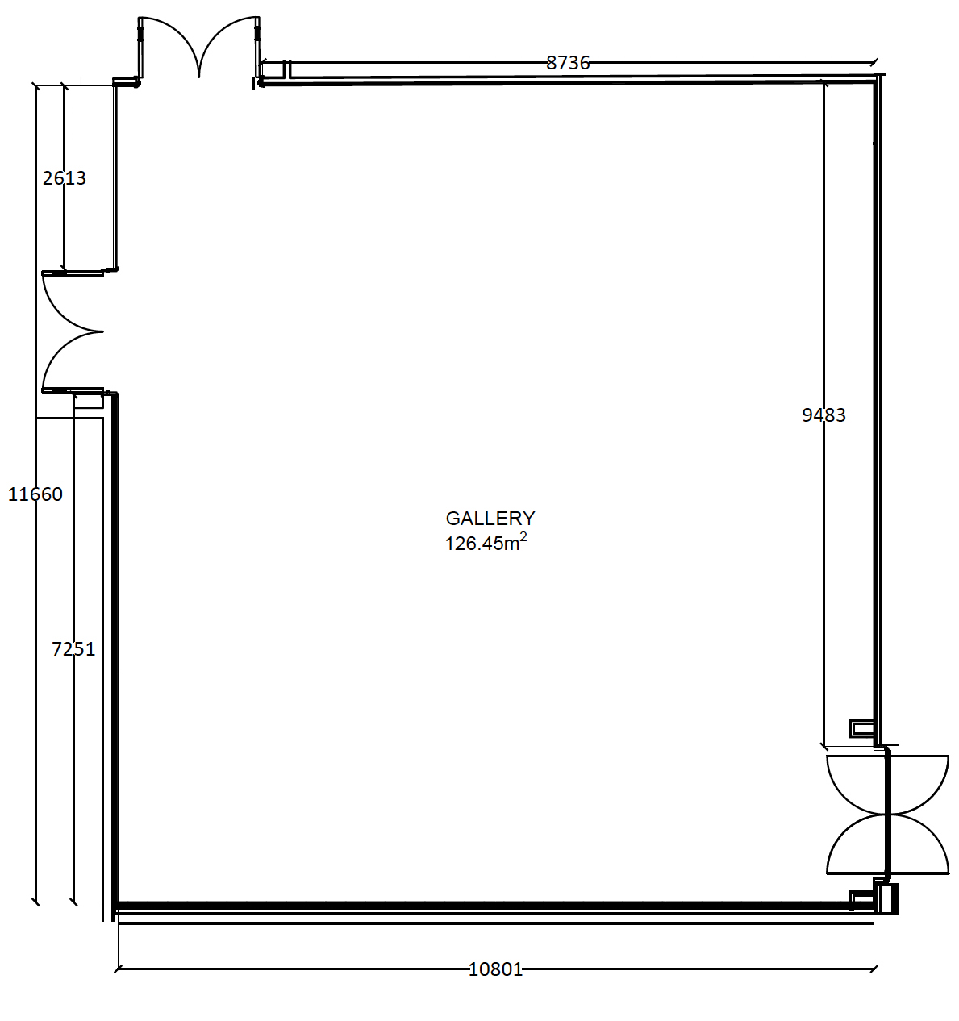

How to apply

Please ensure your application includes the following:

- A short biography/research profile. In the case of a collective application please include biographies of all applicants.
- A project outline/curatorial rationale that demonstrates the aforementioned priorities.
- An overview of the proposed exhibition that indicates how the space will be used, any curatorial and/or technical requirements, public programme and/or an accompanying publication.
- A current CV and any electronic publications that may assist with your application.
- Four or five high resolution images (at least 300dpi) with accompanying credits (title, date, medium and any copyright details).

Please note
- The exhibition format is not suited for all research or research-practice; we strongly encourage you to reflect on the role of the exhibition in your research process including the arrangement of visual materials and communication of research findings.
- We plan our curatorial programme at least one year in advance.
- Priority will be given to staff members who haven’t exhibited in the Blenheim Walk Gallery within the last 8 years.

Submission
Please email the following form and attachments as a sigle .pdf to the Curatorial Team (curatorial@leeds-art.ac.uk). We realise that text-based applications do not suit everyone, so if you would like to apply in a different way, or if you require this application form in a different format, please contact the Curatorial Team (curatorial@leeds-art.ac.uk).

Selection Process
Proposals are considered by the University Curator in consultation with External Advisers. We will endeavour to respond within three calendar months, but please be aware applications take time to consider.

Submission Form

Name: | Surname:
Role:

Email: | Website:
Mobile: | Social media:
Biography/Research Profile:
(max. 200 words)

Project Outline/Curatorial rationale:
(max. 1000 words)

Overview of proposed Exhibition:
(max. 500 words)

Title of Exhibition:

Details and size of work (if known):

Budget:

