ANNUAL RESEARCH REPORT
2021/22

Originator: Prof Sam Broadhead
Date:

Contents
1) Research time and staff proposals 3
2) Bids for external funding & externally funded projects in 2021/22 3
3) External awards 4
4) Internal events 4
5) External events, exhibitions and publications by ‘teaching and research staff’ 2021-22 5
6) External events, exhibitions and publications by staff who have a significant responsibility for research as part of their role 2021-22 14
7) The Research environment: Invited talks/ reviewing/editorial work/chairing panels 19
8) Ethics 23
9) Exhibitions programming 23
10) Research Excellence Framework 2021 submission 23
11) Guild HE/Research 25
13) Action plan progress 2021-22 31
15) Action plan 2021-2022 34

Research time and staff proposals
The overall aim of the research strategy is to enhance students’ learning by staff being engaged in their own research practices and to bring research funding into the University. Within the context of Leeds Arts University (LAU) research is investigating; rediscovering or making a new contribution to knowledge in a chosen specialist field of study/practice that is open for scrutiny through peer review. Scholarly activity is defined as surveying existing developments in the researchers’ field, these developments may be practiced- based or technical as well as academic or theoretical; acquiring knowledge in order to keep up to date with developments in a specific area. Scholarship is similar to Continuous Professional Development (CPD) but more involved and focuses on a particular area of field of work, it may involve a number of different activities and goes beyond what is strictly necessary to do ‘the job’.

In the academic year 2021-22 the University allocated specific time for research to Higher Education (HE) academic staff on permanent contracts. The basis of the allocation was 15 days for full-time staff and a proportion of this for fractional posts e.g. 0.8 = 12 days; 0.6=9 days; 0.4=6 days; 0.2=3 days.

Clear guidelines are devised requiring the submission of a research proposal and the recording of research outcomes. Proposals were submitted for approval to the Senior Management Team (SMT) and the Ethics Sub-Committee. Research activity was monitored by the Head of Research electronic copies of the proposals provide a record of proposed activity.

Bids for external funding & externally funded projects in 2021/22
Woolley, D. and her collaborator Zara Worth have been awarded Leeds 2023 seed funding for the project: The Web That We Want. They are developing an exhibition and new public artwork which asks - what is the Web that We Want?
Wooley D. 2021 and Davin Watne also received a small grant from Future's Venture Foundation to produce some short animations for Facebook and Instagram adverts based on their research.

QAA Collaborative Enhancement Project, Belonging through Assessment: Pipelines of Compassion (GSA, LAU, UAL).
The project continued throughout 2021-2022 Broadhead, S., da Costa, L., & Hughes, P. et al. 2022 submitted apposition paper 30 May 2022. The project finishes in November 2022 when an interactive book will be published.

KE project with Brigantia.
Knowledge Exchange project with Brigantia, an Arts Council National Portfolio Organisation is underway, the aim is creating a curriculum for training socially engaged artists from the Kirklees area. A report has been written that shows the impact on local arts services in Dewsbury.

Developing Research Culture with Visiting Associate Researchers.
Developing Research Culture project is also underway, the aim is to support under-represented researchers so that in the future they may consider doing a research degree. The project will culminate into a show in the Blenheim Gallery during the Autumn.

External awards
Pearson, J. won the Eisner Award for 'Best Painter / Multimedia Artist (Interior Art) in July 2021 for his graphic novel 'Blue in Green', published by Image Comics. [The Eisner Awards are essentially the ‘Oscars’ of the comics industry].

Gaffney, S. 2021 was short-listed for the Working Drawing Award 2021 part of the prestigious Trinity Buoy Wharf Drawing Prize 2021.

Internal events
Dawn Woolley and Paula Chambers devised and coordinated Re/Generative Things, a Thing Power research project using the vitrine spaces in the University that will culminate in a publication.
Broadhead, S. 2021 organised with Dr Dawn Woolley the third symposium, Expanding Communities of Sustainable Practice [online], Leeds Arts University: 15-16 October 2021. Keynotes from Maxwell Ayamba founder of the Sheffield Environmental Movement and Dr Max Liboiron Associate Professor in Geography at Memorial University and founder of CLEAR.
Broadhead, S. is developing the Communities of Inquiry work with Black and Minority Ethnic students research project in collaboration with the Access and Widening Participation team.
Research sharing event on the 17th May 2022: Norton, F. presented their PhD research asking, How can we as educators encourage our students to think differently about academic skills we expect them to use in the completion of reflective course work or positioning statements, report writing or even developing a coherent argument for dissertation writing? Snare, E. presented ideas from the book chapter they had just written. Posing suggestions made for how educators may attempt to navigate the intersection between arts education, industrialisation and The Earth in the future.

External events, exhibitions and publications by ‘teaching and research staff’ 2021-22

Papers published in  peer-referenced journals/ Book chapters/Books/Conference Proceedings | Conference presentations | External  Exhibitions/screenings
Postgraduate
Norton, F. (2022) ‘Pop-up exhibitions and wicked problems: Reflections on a Critical Thinking Club' in Broadhead, S. (Ed) Access and Widening Participation in Arts Higher Education. London: Palgrave Macmillan. | Norton, F. (2022) ADEMA Escuela Universitaria, Art week. ‘Connecting Arts Practices: Developing Critical Thinking Skills and Community with Transdisciplinary Postgraduate Arts Students’. Palma in Majorca, Spain. March 24-25-26 2022.  Broadhead, S., Baines, M. & Norton, F. (2021) British Education Research Association BERA. Engaging Mature Students in Critical Thinking strategies. Symposium Paper given at an online conference. September 2021. 14/09/2021 | Norton, F. Re/Generative Things Vitrine Project, Leeds Arts University, group show/ research activity, 28 April - 29 July 2022.  French, M. 2021. 360° fulldome film Climate Crimes has been selected to screen at the Glasgow Planetarium as part of the COP26 Green Zone Cultural Program. 26th UN Climate Change Conference of the Parties (COP26) in Glasgow on 31 October – 12 November 2021.  French, M. & Pilling, F. 2022. Curating Climate: Ecological Creative Practice Workshop. Grizedale Forest, Forestry England & Signal Film and Media, Cumbria. 21-26 July 2022.  Taylor, S. Paul, L. 2022 Backgrounds and Backdrops, joint exhibition B Gallery, Leeds Arts University, 24 February - 27 April 2022.
Art and design
Barker, G. 2021.Drawing the embodied mind: A project report on research into interoception, PSIAX i2ADS,5, :17–24. ISSN 1647-8045  Barker, G. 2021. Revealing the invisible: The virus is looking at you. Journal of Visual Political Communication, 77 (11). pp. 61-87.  Barker, G. & Coleman, D. 2021.The Screen will not fill the Void (Artefact), Workshop Press. ISBN 9781006871146  Barker, G. 2021. Votive Cards Artefact dissemination: Leeds Arts Health and Wellbeing Network (LAHWN) https://beyondmeasure.mailchimpsites.com/garry-barker and Miracle  Immanence Gallery, 21 Avenue du Maine, 75015 Paris.  Hodson, M. 2021. At This Very Moment (Artefact) Cicada books ISBN 978-1-908714-92-3 26 pages. The book was show cased at Bologna International Book fair 2022 and is being published in Mexico, Italy and Korea.  Bottomley, R. 2022. Football: Designing the Beautiful game. Watson, E. and Bird, J. (Eds). Design Museum. 1872005616  Virgoe, A. 2021. Nexus, veil: Robert Ryman and the equivocal spaces of abstraction. Journal of Contemporary Painting, 7(1-2), 39-59.  Deakin, N. Dyer, J. 2022. Graphic Events: A Realist Account of Graphic Design. Onomatopee. ISBN 978-94-93148-66-6 | Almaguer Buentello, D., Harrison, D. and Snare, E. 2021.“A Simple Vista: Cultural Variability as a Dialogue Between Students” 7th International Visual Methods Conference, Cape Town, South Africa: 13 – 15 December 2021.  Snare, E. and Papathanasiou, T. 2021. Global Fashion Conference. Warsaw. 21-23 October 2021.  Almaguer Buentello, D., Harrison, D, and Snare, E. 2021. Decolonising Design. 7th International Visual Methods Conference (IVMC) South Africa by Cape Peninsula University of Technology (CPUT), 13-15 December 2021.  Smith, M. 2021. Belonging, Assessment and Industry. Belonging Through Assessment: Pipelines of Compassion symposium. 21 October 2021.  Gaffney, S. & Spencer, N. 2021. CALM assessment project. Belonging Through Assessment: Pipelines of Compassion symposium. 21 October 2021.  Hooper, S. & Collins, D. 2021. Repositioning Sustainability within BA (Hons.) Visual Communication. The third symposium, Expanding Communities of Sustainable Practice [online], Leeds Arts University: 15-16 October 2021  Snare, E. 2021. Critical Place-Based Pedagogy for Art Education: An  SDG Alternative? The third symposium, Expanding Communities of Sustainable Practice [online], Leeds Arts University: 15-16 October 2021.  French, M. 2021. The Ecological Observatory. The third symposium, Expanding Communities of Sustainable Practice [online], Leeds Arts University: 15-16 October 2021.  Roe, K. 2021. SLOW (down): Craftsmanship in contemporary fashion. the third symposium, Expanding Communities of Sustainable Practice [online], Leeds Arts University: 15-16 October 2021.  Perez, A. 2021. Sustainability in HE: An Active Teaching Approach for Creative Courses. The third symposium, Expanding Communities of Sustainable Practice [online], Leeds Arts University: 15-16 October 2021.  Riches, C. 2021. Invited talk (online) for Fashion Illustration and Drawing (FIDA) worldwide on the tactility in drawing and mark making in fashion arts.  Hooper, S. 2021. Repositioning Sustainability within BA (Hons.) Visual Communication (collaboration with D.Collins) at LAU Expanding Communities of Sustainable Practice.  Mills, J. 2022. Twists & Loops: Illustrating Ecologically. ICON11 – The Illustration Conference. Kansas City, USA. 29 June – 02 August 2022 | Bergman, L. 2021. Rheums, Digital media  www.rheums.me performed live in June 2022  Welding, P. Home Occupations. FORMAT International .  Janie Tweddle & Nicola Knight  Belonging: Fashion & A Sense of place Exhibition Fashion Gallery, Bankfield Museum, Halifax: 18 September 2021-  05 May 2022. https://vimeo.com/685431409  Steans, D 2021 Curtainz Creative project  Whitechapel Gallery, MIT Press, Koening Books @ Whitechapel Gallery ISBN 978-0-85488-290-8 (Whitechapel)  ISBN 978-0-262-54303-3 (MIT) https://lau.repository.guildhe.ac.uk/id/eprint/17745/  Young, N. 2021.Chernobyl: Thirty years on, Café Blah, Manchester. 16-20 October 2021.  Young, N. 2022. Chernobyl: Thirty Years On. The Rotunda, Leeds Arts University. 24 February - 27 April 2022.  Simpson, B. 2021. Babe’s Vision. (What a child sees – reinterpreted) Visual media.  Hooper, S., Broadhead, S. and Gonnet, H. 2022. Learning Returns: Supporting mature students in art and design The Rotunda, LAU: 12 May -21 July 2022.  Mills, J. and Karol, B. 2021. A piece of turf, Yorkshire Artspace, Sheffield: 20 May 2021- 6 June 2021.  Riches, C. 2021. Fashion illustration for McQueen dress . Knight, N. and Tweddle, J. 2021-22. BELONGING: Fashion & A Sense of Place. Bankfield Museum. 18 September 2021 – 5 March 2022.  Riches, C. 2021. Fashion illustration. The Intersection of art and fashion. The Virgil Catherine Gallery. Illinois USA, 17 August -17 September 2021.  Dale, N. 2021. It Is Solved by Walking. The work was performed live at Islington Mill, Salford, UK and live-streamed at Begehungen Festival, Germany: 12-15 August 2021. The work was reviewed by Mike Pinnington in ‘The Double Negative’.  Dale, N. 2021. Strike. The work was screened at Begehungen Festival, Germany and Islington Mill, Salford, UK: 12-15 August 2021. The work was reviewed by Mike Pinnington in ‘The Double Negative’.  Penman, M. D. 2021. Sir Gawain and the Green Knight (zine) made public: 13 November 2021  https://www.moorereppion.com/greenknight/  https://mdpenman.bigcartel.com/product/sir-gawain-and-the-green-knight  https://www.worldcomicbookreview.com/2022/02/03/sir-gawain-and-the-green-knight-review/  11 November 2021: https://www.brokenfrontier.com/sir-gawain-and-the-green-knight-reppion-penman/  Riches, C. 2022. A drawing of Halston with Pat Cleveland in 1977. Exhibition event / Charity Auction Linked with Halston Archives Fashion Scholarship Fashion Institute New York: 24 April 2022.  Boiangiu, G. M. (2022) Weeds. 'Following Threads' exhibition at Bradford Industrial Museum, from 26 February 2022 - 23 January 2023.  Chambers, P, 2022. Working Girls, a solo exhibition, The Whitaker, Rawtenstall, 14 April - 12 June 2022.  Broadhead, S. & Hooper, S. 2022. Learning Returns. The Rotunda, Leeds Arts University: 12 May – 21 July 2022.
Music performance and film
Huxtable, J. (2021), Pragmatic White Allyship for Higher Education Popular Music Academics, IASPM Journal Vol. 11 No. 1: Special Issue: Crises at Work: Potentials for Change?, pp.94-99.  This output was published on 15/10/21, is locatable at https://iaspmjournal.net/index.php/IASPM_Journal/issue/view/77 and is included on the repository at https://lau.repository.guildhe.ac.uk/id/eprint/17708/  Forkert K., Nulman E., Wilde P., Huxtable J., Nahaboo Z., Armstrong T., Windsor E.,  Academic Activism: Revisiting Edward Said’s ‘Representations of the Intellectual’ (1993), Philosophy and Theory in Higher Education Journal - Special Issue – Activism in the 21st Century: Challenges and Opportunities  Revisions and edits of this article took place through AY21/22. Following round 2 of editorial consideration, this is expected to be published in late Summer/Autumn 2022  Huxtable, J. (2022), Music Theory in Higher Education: The Language of Exclusion?, pp.181-200 in Broadhead, S. (ed.), Widening Participation in Arts Higher Education, Palgrave Macmillan https://link.springer.com/book/10.1007/978-3-030-97450-3  Huxtable, J. (2022), Ideological Extrojection: The De-Neoliberalization of UK Music Education, in Powell, B.P. & Smith, G.D. (eds.) (forthcoming 2022) Places and Purposes of Popular Music Education: Perspectives from the Field, Bristol: Intellect  The editing and publication presentation of this took place over AY21/22. This is has now gone through final formatting revisions and will be published December 2022 https://press.uchicago.edu/ucp/books/book/distributed/P/bo186918521.html  Huxtable, J. (2022), ‘Performance’ measures as neoliberal industrialisation of higher education: A policy archaeology of the Teaching Excellence Framework and implications for the marginalisation of music education, in Broadhead, S. (ed.) (forthcoming 2022) The Industrialisation of Arts Education, Palgrave Macmillan  https://www.brownsbfs.co.uk/Product/Broadhead-Samantha/The-Industrialisation-of-Arts-Education/9783031050169  Attah, Tom (2022) The boy can’t help it: Little Richard’s disruption and re-construction of screen performativity. In: Pop Stars on Film. Bloomsbury. ISBN 9781501372513 (In Press) | Huxtable, J. & Zao, S. (2021), Royal Musical Association 57th Annual Conference, Newcastle University; Jason Huxtable and Sanba Zao, Decolonisation of Percussion Curricululm, 14-16/09, https://conferences.ncl.ac.uk/rma2021/conferenceprogramme/ (This presentation is connected to AY21/22 Research Proposal Activity)  Huxtable, J. (2022), Leeds Beckett University, Visiting Lecture/Workshop, Stick Kinesthetics: Developing Technical Efficiency for Healthy Hands, April 2022  Huxtable, J. and Zao, S. (2022), Middlesex University Guest Lecture, The Vodou Rhythms of Haiti: Context Symbolism and Performance, March 2022, (This presentation is connected to AY21/22 Research Proposal Activity)  Huxtable, J. 2022. Belonging through assessment: Pipelines of compassion. Working group discussion around Policy Archaeology methodology. Slides from the session can be found here:  https://drive.google.com/file/d/1JwrAHZTYlkMfdum6U0kox_2jEocDi6Vm/view?usp=sharing  Attah, T. 2021. RMA annual conference, Armstrong Building, Newcastle University. 14 Sep 2021-16 Sep 2021.  Huxtable, J. 2022. Decolonisation of Percussion Curriculum: Representing Haitian Percussion - A Situational Praxis. International Association for the Study of Popular Music (IASPM) – International Drum Kit Studies Conference, Boston University, Boston (MA), 9-10 September 2022.  Attah, T. 2022. IASPM UK & Ireland 2022 branch conference in Liverpool. 31 August – 1 September 2022. |  | Huxtable, J. 2022. Inspired By Bragg: Aurora Percussion Duo: Metal, February 2022, Concert, University of Leeds, https://www.leeds.ac.uk/study/events/event/93/inspired-by-bragg-aurora-percussion-duo-metal  Attah, T. Blues in the Woods Performance, Blues in the Woods. 3-6 June 2022.  Chimiak, T. (2022) Tailor-made Maternal PKU Diet Education and Women with PKU: Reproductive Experiences and Needs Throughout the Journey. [Video]
Creative Writing
Gregory, S. 2021. Three Graves [a creative work, novel]. Bluemoose Books.

Tobias-Green, K. 2022. Deconstructing Writing in Arts Education and Beyond. In Access and Widening Participation in Arts Higher Education (pp. 159-177). Palgrave Macmillan, Cham.

External events, exhibitions and publications by staff who have a significant responsibility for research as part of their role 2021-22
Papers published in  peer-referenced journals/ Book chapters, Books, Conference Proceedings | Exhibitions and Screenings | International and National  conference presentations
Woolley, D. and Worth, Z. 2022. ‘Creative Consumption: Art About Eating on Instagram’ in #FOODINSTAGRAM: Identity, Influence, Negotiation, Illinois: University of Illinois Press, 2022 9780252086540 101-112  Woolley, D. 2022. ‘The Quantified Self, The Ideology of Health and Fat’, in The Body Productive Book Chapter  London: Zero Books  Tsionki, Marianna. 2022. Imagined Mappings of Geopolitical Power: Liquid Borders, Military Infrastructures and Ecological destruction in the South China Sea. In: Visual Culture Wars at the Borders of Contemporary China. Palgrave Macmillan, Singapore. ISBN 978-981-16-5292-9  Tsionki, M. 2022. Networks of Trust, Exhibition Essay, Really Simple Syndication Press, Copenhagen.  Tsionki, Marianna. 2022. Unknown Fields Division – Rare Earthenware. In: Postcards from the Anthropocene: Unsettling the Geopolitics of Representation. dpr-barcelona, Barcelona. ISBN 978-84-122529-1-0  Broadhead, S. (Ed.). 2022. Access and Widening Participation in Arts Higher Education: Practice and Research. Springer Nature. ISBN: 978-3-030-97450-3 ISBN: 978-3-030-97449-7  Broadhead, S. 2021. What Eliza and Jake did next: Learning beyond access to HE art and design? In: Adult Education as a Resource for Resistance and Transformation: Voices, Learning Experiences, Identities of Student and Adult Educators. Faculty of Psychology and Education Sciences, University of Coimbra, Portugal; Centre for the Research on Adult Education and Community Intervention (CEAD), University of Algarve, Portugal; European Society for Research on the Education of Adults, Coimbra, Portugal, pp. 167-174. ISBN 978-86-80712-40-6.  Broadhead, S., & Macleod, D. 2022. Accessing Art and Design Higher Education: A Comparative Study of Access Courses Delivered in Further and Higher Education. Access and Widening Participation in Arts Higher Education: Practice and Research, 95-139.  Whittaker, R., & Broadhead, S. 2022. Disaggregating the Black Student Experience. Access and Widening Participation in Arts Higher Education: Practice and Research, 51-72.  Broadhead, S. 2022. The Janus of the Access to HE Diploma: Rethinking qualifications, units, credits and levels. W. Turnbull, H. Woolf (Eds.), Widening Access to Higher Education in the UK: Developments and Approaches using Credit Accumulation and Transfer (pp.35-49) London, Open University Press. (ISBN: 9780335250592)  Hill, V., Broadhead, S., Hughes, P., Bunting, L., Currant, N., da Costa, L., Greated, M., Mantho, R., Salines, E. and Stevens, T. 2022. QAA Collaborative Enhancement Project, 2021 Belonging through Assessment: Pipelines of Compassion. [Report] https://lau.repository.guildhe.ac.uk/id/eprint/17786/  Broadhead, S. Thompson, P. & Burns, H. 2022. What are the long-term benefits of investing in art, craft & design in education for learning, culture, wellbeing and society? Preliminary report. APPG Art, Craft and Design and NSEAD Education https://www.nsead.org/files/197d15c23cc9301bb69acb742bd3fdcd.pdf  Broadhead, S. 2021. Exploring adult learning and its impact on wider communities through arts-based methods: an evaluation of narrative inquiry through filmmaking. Dyskursy Młodych Andragogów/Adult Education Discourses, (22), 41-59. Retrieved from http://www.dma.wpps.uz.zgora.pl/index.php?journal=DMA&page=article&op=view&path[]=594  Broadhead, S. 2021. ‘Mature graduates and visual culture learning communities: Working through the covid-19 pandemic’, Hongxia Shan and Cindy Hanson (eds.) Proceedings of Adult Education in Global Times, Vancouver, University of British Columbia: 92-97. ISBN: 978-0-920056-54-7.  Broadhead, S. 2021. Art, craft and design in prison education. In AD (The National Society for Education in Art and Design magazine). Autumn 2021, Issue 32: 16-17. | Woolley, D. 2021. Bois of Isolation - queering gender binaries in the confines of pandemic. Imagining History Exhibition at Oriel y Bont, University of South Wales, Ty Crawshay Building, Treforest. 12 November 2021.  Dawn Woolley 25 March – 30 April 2022 Consumed: Stilled Lives Exhibition  bildkultur Galerie, Stuttgart  Woolley, D. 2022. ‘In Search for the Fountain of Youth’, Divergent Temporalities: Capitalism and the Conquest of Space-Time conference, Panteion University, Athens, May 26-28 2022  Woolley, D. 2022. Group exhibition – in collaboration with Davin Watne, Joy and Other Feats of Strength, The Charlotte Street Foundation Gallery, Kansas City, 10 June – 23 July 2022.  Woolley, D. 2022. Solo exhibition - Consumed: Stilled Lives, bildkultur Galerie, Stuttgart, 25 March – 30 April 2022.  Woolley, D. 2022. Group exhibition - New Talents, Kommunale Galerie, Berlin, 30 January 30 – 27 March 2022.  Woolley, D. 2021. Group exhibition - Imagining Histories, Oriel y Bont, University of South Wales, Pontypridd, 1st November – 17th December 2021.  Woolley, D. 2022. Group exhibition - Food Matters and Materialities: Critical Understandings of Food Cultures Conference, Virtual Exhibition, collaboration with Zara Worth (Leeds Beckett University), Carleton University, Ottowa, Ontario, Canada, September 22-25, 2021.  Tsionki, M. 2022. Networks of Trust, Research Exhibition, SixtyEight Art Institute, Copenhagen, 6 May – 18 June 2022. including Networks of Trust, Exhibition Essay, Really Simple Syndication Press, Copenhagen.  Broadhead, S., Hooper, S. and Gonnet, H. Learning Returns: Supporting mature students in art and design, LAU: 12 May -21 July 2022. | Baines, M., Broadhead S., Norton, F. (2021) British Educational Research Association (BERA) Annual Conference. ‘A Mature Learners Journey into the Arts: Determining Pedagogic Principles and Practice in Widening Participation’ Online Presentation.  Baines, M and Edwards, D. (2021) National Education Opportunities Network (NEON) Summer Symposium. ‘Innovation in Creative Arts Widening Participation Outreach’ Online presentation.  Baines M. 2021.Their defining moments: Critical incidents and influences for progression into post compulsory education in the Arts. International Practice Focused Research in Education Conference (IPFREC).University of Sunderland. Online presentation  Tsionki, M. 2021. Participant in S3 – Aquaphobia and Beyond: The Water Politics of Representation Anthropocene Campus Venice. Venice, 11-16 October 2021.  Broadhead, S & Hooper, S. 2022. Learning Returns: Experiences of mature students in art and design captured through YouTube. Adult education in times of crisis and change: perspectives on access, learning careers and identities. ESREA Access, Learning Careers and Identities Network Conference. University of Algarve, Faro, Portugal.14-16 July 2022.  Broadhead, S. 2021. Mature Students and Visual Culture Learning Communities in Covid19 Pandemic: Mature students matter in art, design and craft education. BERA Conference 2021. 13-16 September 2021.  Woolley, D. 2022. ‘God-shaped hole’ in collaboration with Zara Worth (Leeds Beckett University), DigitalPaintingPhotography symposium, University of Derby, 21st and 22nd October 2021.  Woolley, D. 2022. ‘The Deviant Leisure of Gym Bodies, Militaritarized Branding and Fascistic Creeps’ in collaboration with Jason Luger (University of Northumbria), Masculinity in Times of Change symposium, Masculinity, Sex and Popular Culture Research Network in collaboration with Men in Movement V: Masculinities and Feasible Futures, Monday 20th to Wednesday 22nd September 2021.

The Research environment: Invited talks/ reviewing/editorial work/chairing panels
External Examiner for Research Degrees

Attah T. Examined a PhD in March 2022.
Broadhead, S. 03 May 2022. PhD. Joyce Chen, ‘Working and Learning Together:
The Lived Experiences of Further Education Teachers Engaging with Joint Practice Development as a Model of Collaborative Enquiry for Professional Learning’ University of Sunderland.

Invited talks

Woolley, D. 2022. Artist and Research Talk, University of Lincoln, 2nd March 2022.
Woolley, D. 2021. Artist and Research Talk, Contemporary Arts Society for Wales, 19th Oct 2021.
Steans D. 2021 Participant in Podcast discussing Sardonic Harmony commission with Dr Alex Mason and Hardeep Pandhal 2021
Steans D. 2021 Featured artist in Sardonic Harmony commission with Castlefield Gallery and Manchester Hip Hop Archive. 2021
Steans D. 2021 Artist talk as part of Axis Web Members Event ‘Art in Words’. 2021
Broadhead, S. 2022. Invited speaker summing up the conference at the closing event and a panel chair. Adult education in times of crisis and change: perspectives on access, learning careers and identities. ESREA Access, Learning Careers and Identities Network Conference. University of Algarve, Faro, Portugal: 14-16 July 2022.
Broadhead, S. 2021. Panel member on Pass/Fail assessment. Belonging Through Assessment: Pipelines of Compassion symposium. 21 October 2021.

Panel Chairs and members

Dawn Woolley joined the steering committee for Feminist Gender Equality Network (FGEN) led by Professor Sally Hines (Sheffield University) and Dr Natacha Kennedy (Goldsmiths University). As a member of the conference committee she helped to organise Living Gender in Diverse Times, an international conference at Shoreditch Town Hall (April 2022). Dawn is also the Visual Culture stream lead. To date they have run an instagram project (#LoveMyGender) and a placard-making workshop. On 23rd July 2022 they are curating a day of workshops, film screenings and performances by trans and non-binary artists at Ugly Duck, London.

Broadhead, S. 2021. Chair and organiser of seminar session, Mature Students matter in art, design and craft education, BERA Conference 2021 13-16 September 2021.
Tobias-Green, K. 2021. judge on the Aesthetica short story panel and 750-word review of the experience will appear in the anthology.
Smith, A. Chair of Pedagogy 1 Strand, the third symposium, Expanding Communities of Sustainable Practice [online], Leeds Arts University: 15-16 October 2021.
Hooper, S. Chair of Fashion Strand, the third symposium, Expanding Communities of Sustainable Practice [online], Leeds Arts University: 15-16 October 2021.
Roe, K. Chair of Pedagogy 2 Strand, the third symposium, Expanding Communities of Sustainable Practice [online], Leeds Arts University: 15-16 October 2021.

Review work
Amelia Couch has written a review of two projects that are part of Wild Eye, a programme by Invisible Dust and Yorkshire Wildlife Trust. Wild Eye: Art & Nature new commissions — Corridor8

Peer review work
Broadhead, S. 2022. invited as peer reviewer for INSTED: Interdisciplinary Studies in Education &Society (Teraźniejszość – Człowiek – Edukacja) 08 July 2022.

Broadhead, S. Peer review for MDPI Arts Editorial Office, 03 August 2022.

Broadhead, S. 2022. peer reviewer for Journal of Buildings since 2022.

Broadhead, S. 2022. peer reviewer for European Journal for Research on the Education and Learning of Adults (RELA) – 11 February 2022.

Broadhead, S. 2022. chapter reviewer for Learning Design Voices edited by Tasneem Jaffer, Shanali Govender & Professor Laura Czerniewicz, Centre for Innovation in Learning and Teaching, Centre for, Higher Education Development, University of Cape Town , South Africa January 2022.

Editorial work
Broadhead, S. & Woolley, D. have begun as guest editors to the special edition of Arts Journal, its title is Visual Arts and Design: Practice-Based Research, the deadline for publications is the 30 November.

Woolley, D., Johnston, F., Sampson, E. and Chambers, P. (Eds). 2022. Curative things: Objects at the Intersection between fashion, art and medical humanities, Palgrave.

Broadhead, S. (Ed.). 2022. Access and Widening Participation in Arts Higher Education: Practice and Research. Springer Nature. ISBN: 978-3-030-97450-3 ISBN: 978-3-030-97449-7

Pathway to impact activity
Woolley, D. 2021. Steering Committee member: Feminist Gender Equality Network, July 2021 – Present.
Conference Committee member: Feminist Gender Equality Network, July 2021 – Present.

Broadhead, S. 2021. Contributed evidence about research and evaluation at an Arts Council England NPO ( National Portfolio Organisation) interview to support creative scene. The bid was successful. This means the project will receive an extension to the programme to March 2025, an additional £660,000 of funding to allocate to the Creative Scene programme and to develop organisation, infrastructure and team; and be part of a family of NPO Creative People and Places nationally. The Creative People and Places NPO’s are seen as a key part of delivery of ACE’s 10 year strategy and so we anticipate opportunities to continue to lead the consortium and apply for this funding in the future.

Baines, M. 2022. Provided evidence for House of Commons Science and Technology Committee’s inquiry on ‘Diversity in STEM’.
https://committees.parliament.uk/work/1639/diversity-in-stem/
https://committees.parliament.uk/writtenevidence/42410/html/

Attah, T. 2022. BBC Radio 2, The Blues Show with Cerys Matthews ‘A Beginner’s Guide to the Blues Part 5: Regional variations – Chicago Blues’ (11th April 2022) – Featured guest and subject expert

Attah, T. 2022. BBC Radio 2, The Blues Show with Cerys Matthews ‘A Beginner’s Guide to the Blues Part 4: Regional variations – Delta Blues’ (4th April 2022) – Featured guest and subject expert

Attah, T. 2022. BBC Radio 2, The Blues Show with Cerys Matthews ‘A Beginner’s Guide to the Blues Part 3: Regional variations – Piedmont Blues’ (28th March 2022) – Featured guest and subject expert

Attah, T. 2022. BBC Radio 2, The Blues Show with Cerys Matthews ‘A Beginner’s Guide to the Blues Part 2: The pioneering women of early blues’ (21st March 2022) – Featured guest and subject expert

Attah, T. 2022. BBC Radio 2, The Blues Show with Cerys Matthews ‘A Beginner’s Guide to the Blues Part 1: Origins of the blues’ (14th March 2022) – Featured guest and subject expert.

Baines, M. 2022 Acknowledged contribution to Parliamentary Office of Science and Technology (POST) and Knowledge Exchange Unit (KEU) advocacy document of underrepresented groups in Parliamentary research.

Knight, N & Tweedle, J (2021-2022) Links to Belonging: Fashion & A Sense of Place– Press
https://museums.calderdale.gov.uk/whats-on/exhibitions/belonging-fashion
How West Yorkshire influences the fashion world, 2021. https://www.bbc.co.uk/news/uk-england-leeds-58585644
Major exhibition combines fashion and a sense of place, 2021. http://news.calderdale.gov.uk/major-exhibition-combines-fashion-and-a-sense-of-place/
Contemporary fashion exhibition opens at Bankfield museum, Halifax 2021. https://www.leeds-art.ac.uk/news-events/news/contemporary-fashion-exhibition-opens-at-bankfield-museum-halifax/
The story of how Yorkshire's mills, moors and canals influenced some of the world's top fashion designers - including Alexander McQueen and Christian Dior 2021. https://www.yorkshirepost.co.uk/lifestyle/shopping/the-story-of-how-yorkshires-mills-moors-and-canals-influenced-some-of-the-worlds-top-fashion-designers-including-alexander-mcqueen-and-christian-dior-3401635
Major exhibition at Bankfield Museum combines fashion and a sense of place, 2021. https://www.halifaxcourier.co.uk/whats-on/things-to-do/major-exhibition-at-bankfield-museum-combines-fashion-and-a-sense-of-place-3378518
Belonging: Fashion & A Sense of Place, 2021. https://fashionexhibitionmaking.arts.ac.uk/belonging-fashion-a-sense-of-place/
Bankfield Museum Celebrates West Yorkshire’s Fashion History, 2021. https://www.livingnorth.com/index.php/article/bankfield-museums-celebrates-west-yorkshires-fashion-history
A curator-led exhibition tour and handling session at Bankfield Museum, 2021. https://www.eventbrite.co.uk/e/belonging-fashion-and-a-sense-of-place-tickets-260057277317#

Research groups

Steans, D. 2022 Founding member of ‘Hyper Banality Fan Club’ temporary artists network with Newbridge Project. 2021-2022

Ethics
Research proposals for the upcoming academic year 2021-2022 were reviewed by the Ethics Sub-Committee. Proposals where the ethical questions had not been considered were given conditional approval on addressing any outstanding ethical issues.

The University has put into place all the requirements necessary in order to be compliant with the Research Integrity. As a minimum, this means that it must be able to demonstrate:
identified a named point of contact who will act as a first point of contact for anyone wanting more information on matters of research integrity, and ensure that contact details for this person are kept up to date and are publicly available on the institution's website .
provided a named point of contact or recognised an appropriate third party to act as confidential liaison for whistle-blowers or any other person wishing to raise concerns about the integrity of research being conducted under their auspices.
published an annual statement on how they are meeting the requirements of the revised concordat.
The University is required to publish an annual statement that has been approved by the Senior Management Team. The annual statement here: https://www.leeds-art.ac.uk/research/research-integrity-ethics/
Compliance will be reported to Universities UK via GuildHE/Research as part of our membership. This year there have been no external queries about our researchers’ ethical practice. Internal issues have been dealt with through the Ethics Sub-Committee.

Exhibitions programming
Like all aspects of the university the Curation and Library services were affected by the Covid-19 pandemic’s lockdowns. Despite the wider challenges and following the programme suspension, in 2022 the Curation and Library Services presented an ambitious programme of research activities including exhibitions, performances and new commissions.

We reopened the doors to the Blenheim Walk Gallery with a major exhibition by international artist, filmmaker and researcher Marwa Arsanios, presenting the complete quadrilogy of Who Is Afraid of Ideology? The exhibition coincided with Arsanios’ participation in Documenta 15. Arsanios’ exhibition was reviewed by Corridor 8 Magazine and Yorkshire Post Culture and was announced on international platform Art & Education.

This was followed by a series of exhibitions presenting practice-based research by LAU colleagues Nicholas Young, Dr Sarah Taylor and Dr Lewis Paul, Prof Sam Broadhead and Sarah Hooper, the Thing Power research group and the LAU Progression Team.

A significant achievement was the UKRI Building Research Culture project, a collaboration with the Research Department supporting the development of emerging researchers, the research environment within the University and the formulation of new narratives in artistic and curatorial knowledge production through collaborative working, and the sharing of expertise and models of research-practice. The project culminated in a research exhibition.

Research Excellence Framework 2021 submission
Embargoed individual results and results for all HEIs were available for download via the REF submission system at 9.00am on 9 and 10 May 2022 respectively. All results were made public on the REF website on 12 May 2022.
Following the publication of results the confidential panel feedback was available in June 2022. Impact case studies were made public on the REF website in June 2022.
Leeds Arts University made a submission to a Research Assessment Exercise for the first time in 2020. The University submitted to two Units of Assessment. The census period for outputs submitted covered the period 2014 – 2020 (adjusted to take account of the Covid 19 pandemic). Since 2011 all HE staff at the University have been appointed on T&R contracts thus defining their responsibility for research and eligibility for submission into an assessment exercise.
A KPI for quality research was set and agreed by the Board of Governors in 2013 – 20% of REF submissions rated as 2* and above. The University exceeded the KPI in both Units of Assessment receiving an overall result of 61% 2* quality rated research again a target of 20% 2 *.

Methodology
Institutions received for each Unit of Assessment (UoA) a star profile (1-4) for outputs (weighting 60%), impact (weighting 25%) and environment (weighting 15%). These were compiled to create an overall quality rating.

Additional information given was the FTE and the percentage (%) of eligible staff submitted. Leeds University submitted 100% of its staff.

UOA 32: Art and Design: History, Practice and Theory
FTE category A staff submitted: 66.79

Percentage of submission meeting the standard for:

 |  | 4* | 3* | 2* | 1* | U/C
Overall quality profile |  | 3 | 13 | 46 | 34 | 4
Sub-profiles | Outputs | 4.3 | 12.9 | 42.9 | 33.2 | 6.7
 | Impact | 0.0 | 16.7 | 33.3 | 50.0 | 0.0
 | Environment | 0.0 | 12.5 | 77.5 | 10.0 | 0.0

UOA 33: Music, Drama, Dance, Performing Arts, Film and Screen Studies
FTE category A staff submitted: 4.20

Percentage of submission meeting the standard for:

 |  | 4* | 3* | 2* | 1* | U/C
Overall quality profile |  | 0 | 11 | 27 | 39 | 23
Sub-profiles | Outputs | 0.0 | 18.2 | 27.3 | 36.3 | 18.2
 | Impact | 0.0 | 0.0 | 25.0 | 25.0 | 50.0
 | Environment | 0.0 | 0.0 | 27.5 | 72.5 | 0.0

Guild HE/Research
The Head of Research continues to attend regular meetings with GuildHE/Research. The University continues to subscribe to shared resources such as the Repository and membership of Vitea.

- The Virtual Environment of Research

LAU Institutional Repository
There are currently 437 items on the Leeds Arts University Repository, 91% of which are full-text and 84% open access. In total we are up to 92,327 downloads, having had 43,786 total downloads in the past academic year (31 July 2021 – 31 July 2022). Since late 2021 download numbers have increased rapidly, but have now evened out at a steady rate of typically around 4000-4500 downloads per month (with an average of 4051.5).
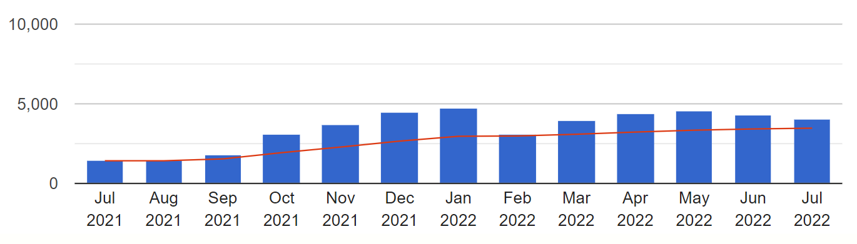
Downloads per month, 31 July ’21 – 31 July’22

This increase in downloads can be largely attributed to a boost in international engagement, as this year we have seen downloads from overseas continue to increase in a positive trend. A large portion of this growth originates in the US, where downloads have increased 410.9% from last academic year (2937 downloads in 2020/21, 15,006 downloads in 2021/22), which vastly overshadows the increase from the UK of 15.2% (16,503 downloads in 2020/21, 19,008 in 2021/22). These US downloads are distributed at an even pace throughout the year from October onwards, in-step with the general upward trend.
We have seen increases from other countries around the globe as well, but in total the largest proportion of engagement remains to be from the UK (at 43.4% of our total downloads for ‘21/22). Of the remaining 56.6%, 34.3% of the engagement came from the US and 23.3% was divided amongst the other 135 countries the repository has reached.

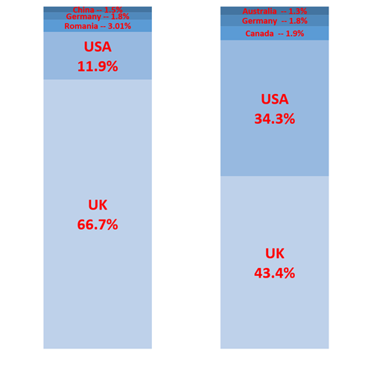
Academic year 2020/21
Academic year 2021/22
Proportion of total downloads per top 5 most downloaded country per year, comparing Academic Year 2021/22 to 2020/21

Totals:

2020/21
UK: 16,503
US: 2937
Romania: 746
Germany: 447
China: 359
2021/22
US: 19,008
US: 15,006
Canada: 826
Germany: 798
Australia: 564

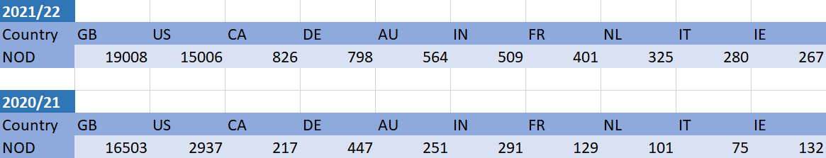
Percentage increase in downloads of the top 10 countries with the highest number of downloads in 2022, comparing data from 2020/21 to 2021/22

In terms of outputs in-scope for the next REF, since January 2021 there have been 70 new research outputs deposited on the LAU Repository. In total, 54 of these outputs are from 2021/2022, which means that they fall within scope (77%). Of those 54 outputs which are in-scope, 49 (91%) are compliant with the UKRI open access policy and are likely to be viable outputs come the next REF (49 outputs out of a total 70 are compliant and in-scope, totalling 70%).
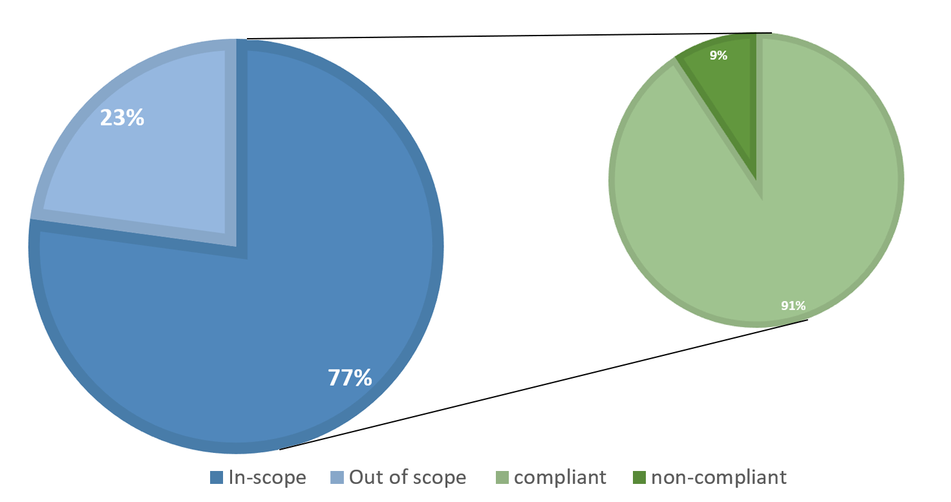
Percentage of in-scope deposits, and proportion of in-scope deposits which are also compliant with UKRI OA policy; 1st January 2021 – 31st July 2022
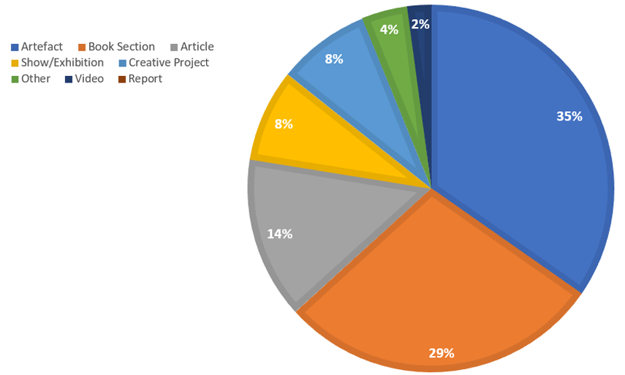
As the chart shows, over a third of these 49 scope/compliant outputs were Artefacts and over a quarter were Book Sections. 94% of the new outputs online are full-text (meaning that a version of the output is on record on the Repository) and 78% of them are fully Open Access.
Distribution of in-scope and compliant outputs by item type
Open Access Training
During the course of this year we have developed Open Access Training videos, which are hosted online on Microsoft Stream. These videos give researchers a detailed overview of Open Access, copyright, ethics, and metadata in relation to research and research outputs, as well as a step-by-step guide to LAU’s procedures with regards to the Repository. This training has been being implemented by HR since January this year, and is mandatory for research-active to complete. We have seen very positive engagement with these videos thus far. These videos will be updated as and when necessary to keep up with the unpredictable and ever-changing landscape of Open Access research.
Portal
There have been a number of updates to the Research and Ethics Portal over the past 12 months. There has been a reorganisation of its contents so that it is more accessible and in-keeping with the university’s accessibility guidelines for online content.
In addition to this, the Research Pathways form and framework are now available on the Portal for staff to view and apply to a Pathway. The Pathways form has been created in an accessible online Microsoft Forms format -- this means that as soon as an applicant completes the form it is automatically sent directly to the Research Team to access and view it. It also means we have all the applications neatly organised and in one place, and we have numerous options available for accessing and downloading this data.
eStudio
The Research & Ethics eStudio page has been revamped to host a variety of research-related content.
There is a section on material relating to Open Access support, where guidance relating to new changes in national research policy and our suggested methods of compliance to this policy will be uploaded and continually updated. In addition, we have links to the Open Access training videos on eStudio (which can be used as an easily accessible reference point for research-active staff).
We are also using this space to host recordings of our Research Tuesday events – so that these can be accessed by those who were unable to attend, or those who want to revisit the discussion.
Moving forward
Moving forward we will be continually updating and re-evaluating our systems and processes as and where needed. As stated earlier, we have several updates for the Repository planned, and the Open Access training will be need reviewing regularly to reflect an ever-changing landscape.
We also aim to continue with Research Tuesday events, with an intention to gradually build up a strong pool of recorded material from these sessions which research-active staff will be able to access online through eStudio.

Action plan progress 2021-22

Objective | Action | Progress
Induct and support new Research Coordinator | - Recruit suitable candidate.  - Ensure they are inducted into the culture of the University including its policies and procedures.  - Ensure that effective line management support is available to the RC.  - Develop the RC so they can manage research finance requests, manage bookings on University system, manage the repository and open access processes and manage the digital environment for research.  - Support the RC in providing relevant data and reports related to Open Access. | A Research coordinator has been recruited and has settled into the role.  Head of Research has undertaken the line management.  The RC has been successfully inducted to all relevant tasks.  Work has been undertaken in developing Diamond Open Access guidance for academic staff.
Develop research environment. | • Thriving research groups.  • Differentiation between three UoA research cultures.  • Research Fellows continue to support the wider research environment. | The Research Fellow has supported the Thing Power research group so that its members have participated in exhibitions, seminars and publications.  There are examples of outputs from each UoA, however, one UoA comprises one course with two staff members, so creating a relevant research culture is very challenging.
Identify and work with validating partner to develop regulation, policy and procedures related to doctoral study at the University. | • Submit documents for scrutiny of proposed validating partner.  • Sign an agreement with the validating partner that serves the interests of both parties.  • Design policies and procedures for PhD students. | This has been suspended due to a re-structure of who has significant responsibility for research in2022-2023 and going forward.
Evaluate REF2021 performance and create updated and responsive research strategy. | • Review and evaluate the outcome of REF2021.  • Give some time and space to create critical distance so that a focused and responsive research strategy can be design.  • Disseminate the Strategy through the deliberative structure. | The results of REF 2021 have been disseminated to the Research Committee on Friday 13 May 2022 and subsequently to the Board of Governors.  The results informed a decision to target staff who wanted to be researchers through two routes (post-doctoral and Early Career).  All submitted research development plans will be reviewed in a two-stage process. Both stages will assess plans against the stated pathway criteria and evidence expectations. The first review period will January 2024.  Stage one: Review Panel comprising Research Fellow, the University Curator and Professor of Research (Innovation and Development) chaired by the Head of Research to review research development plans against criteria and make recommendations to an Approval Panel.  Stage two: Final Approval Panel membership VC and PVCA.  It should be noted that staff who are defined as research active will be required to undertake an annual research review which will comprise an evaluation of how well they have met their goals according to the three-year milestones in an approved research development plan.  Research time allocated will be assessed on an individual basis and there may also be access to funds to support approved research activities.

Action plan 2022-2023
Objective | Action | Responsibility
Embed new structure for managing research | - Plan panel meetings  - Hold panel meeting to consider both routes  - Recommend applicants to the routes to the VC and Pro-Vice-Chancellor  - Complete process by December 2022 | PVCA, HoR and Research Team
Write a clear and purposeful Research Plan for next 5-7 years. This should include an impact strategy. | - Draft plan  - Approve through deliberative structure | PVCA
Develop ethics and research integrity | - Policy review of Ethics  - Approve through deliberative structure | Research and Ethics Committee
Develop post doc researchers so they contribute to impact and environment | - Training days  - Impact plan/call out | PVCA, HoR, Research and Ethics Committee
Ensure open access guidance is up to date and followed by all researchers | - Training days  - Update training videos  - Presentation at Research Committee | Research Coordinator and Researchers
Support plan for different UoAs, | - Subject focused seminars | Research Coordinator, HoR and Researchers

