Annual Research Report
2022/23

Originator: | Prof. Sam Broadhead
Date: | October 2023

CONTENTS

1. Pathways Proposals 2023 2
2. Research costs and analysis 2
3. Research activity: Pathway 1 3
4. Research activity: Pathway 2 3
5. Internal funding outside the pathways process 3
6. External awards 4
7. Internal events 4
8. Research activity: non-Pathway staff 6
9. Research degree preparation 6
10. Contributions to the Research base 6
11. Impact activity and public engagement 7
12. Ethics and Research Integrity 8
13. The University Curator’s Report 8
14. Partnerships 9
15. GuildHE Research 10
16. The Institutional Repository and eStudio 12

Pathways Proposals 2023

In academic year 2022-2023 the Pathways approach to research management was instigated. Academic Higher Education staff were invited to apply for a research pathway. Pathway 1 comprises researchers with a PhD and an active research profile. Pathway 2 comprises Early Career Researchers who may or may not have a PhD and are relatively new to research. 42 Pathways applications were received, 12 for Pathway 1 and 30 for Pathway 2. Of the applications received, 11 of the Pathway 1 and 15 of the Pathway 2 proposals were successful. The Pathways programme started in December 2022.

Successful applicants were invited to apply for research time and funding through the Research Days & Budget Request Form, work is being undertaken to automate this form to ensure it drives an efficient process. Pathway 1 researchers were allocated £1500 per annum and Pathway 2 £1000.

Research costs and analysis

The following gives a breakdown of the full costs of research for the University:

Research pay costs £325,176
Non pay expenditure actual £22,243
Total pay and non pay costs actual £347,419

Full economic costing:
Indirect £226,004
Estates £27,160

Total full economic costs £600,583
Research Income £461,022

Recovery of costs based on UKRI indirect cost rate 77%

From the budget allocated for the research department to fund towards outputs, the largest portions of expenditure were on hotel accommodation (£3,864, 16.95%) and air travel (£3,484, 15.28%), with materials (e.g. art materials, printing costs) ranking as the third largest expense (£2,977, 13.06%).

In Pathway 1, 7 out of 11 researchers claimed for funding; whereas in Pathway 2, it was 6 out of 15 researchers. In terms of Research days taken, in Pathway 1, 3 out of the 7 researchers on teaching and research contracts took research leave, whereas in Pathway 2, 11 of 15 took research leave. There are a range of reasons why 7 researchers did not claim days or funds from the research budget. These were: not being at the stage in their research where funds were needed, being on extended staff absence and leaving research activity until the end of the summer term. All researchers will be completing an annual review and reflecting on their progress towards their outputs.

Research activity: Pathway 1

Artefacts, Exhibitions, performances and screenings. | Conference/symposium presentation | Publication | Estimated FTE
Unit of assessment 32: Art and Design: History, Practice and Theory
20 | 18 | 9 | 6.76
Unit of Assessment 33. Music, Drama, Dance, Performing Arts, Film and Screen Studies
1 | 0 | 1 | 1
Unit of Assessment 27. English Language and Literature
0 | 0 | 0 | 1

Research activity: Pathway 2

Artefacts, Exhibitions, performances and screenings. | Conference/symposium presentation |  | Publication | Estimated  FTE
Unit of assessment 32: Art and Design: History, Practice and Theory
4 | 0 |  | 2 | 9.46
Unit of Assessment 33. Music, Drama, Dance, Performing Arts, Film and Screen Studies
2 | 1 |  | 3 | 2.64
Unit of Assessment 27. English Language and Literature
0 |  | 0 | 1 (ex-member of staff) | 0

Internal funding outside the pathways process
The University’s Research Fellow applied for and received funds (£4500) from the Knowledge Exchange budget to develop an APP based on their selfie research with the intention that this would lead to further impact via a series of workshops with a range of different social groups and publics.

Knowledge Exchange funds allocated £700 to host a book launch of The Industrialisation of Arts Education (2023, Palgrave MacMillan) in partnership with the Careers, Employability and Enterprise department on 30 June 2023.

External awards
The University’s Research Fellow has been successful in collaboration with the University of Southampton (amongst others) in gaining ESRC research funding (£3,458) for 'Queer Joy as Digital Good' research project, that will run from 01 August 2023 to 31 March 2024.
They have also been successful in gaining Arts Council England Funding (£28,776) and a grant from The Elephant Trust (£1960) to create a new body of work called My #Rebel Selves project, two exhibitions and workshops. Arts Council England and the Elephant Trust is awarded to the researcher and is an indicator of quality that the work received external peer reviewed funding.

A Pathway 1 Researcher has had their poem, Golden Bird Sestina, nominated by the editors of ‘Haus A Rest’ online zine for 'Best of the Net Anthology Prize’ run by https://bestofthenetanthology.com/submissions/

Internal events

  - Training

Owing to the many changes happening in open research post-REF 2021, four researcher development sessions have been delivered this year. All pathways researchers were invited to the sessions, academic staff not yet on a pathway but interested in research could also attend. These sessions were recorded and have been made available for those who were unable to attend on the Research eStudio page.

The breakdown of the sessions is below:

DATE | TIME | TALK | PRESENTER | LOCATION
08 March | 16:00 – 17:00 | Open Access publishing | Henry Gonnet and Prof. Sam Broadhead | B1.2.33 (fashion seminar room)
15 March | 16:00 – 17:00 | Repository Criteria and quality indicators | Prof. Sam Broadhead and Henry Gonnet | B1.2.33 (fashion seminar room)
29 March | 16:00 – 17:00 | Impact  (What is impact?)  (Examples of impact work) | Prof. Sam Broadhead and Garry Barker | B1.2.33 (fashion seminar room)
18 April | 16:00 – 17:00 | Research Integrity | Prof. Sam Broadhead and Henry Gonnet | B1.2.33 (fashion seminar room)

  - Research sharing events
Two research-sharing events were hosted, one on 13 September 2022 and one on 11 October each with two researchers presenting. These events operated on a rolling open call basis where researchers could share their current projects with their internal peers and receive feedback.

In addition to the research-sharing events, from May – June 2023, the University Research Fellow hosted a series of ‘Performance and Narrative’ seminars for researchers and Postgraduate students. 'Performance and Narrative' was an interdisciplinary seminar programme focusing on practice-based research projects that engage with performativity and narrative in creative ways. Researchers from Leeds Arts University, Northumbria University, University of Huddersfield, Leeds Beckett University and the University of Leeds shared their research, followed by informal discussions that drew out connections between their respective practices:
Session 1: 3rd May, 16:30 - 18:00 - Zara Worth & Dr. Dawn Woolley -
Session 2: 10th May, 16:30 - 18:00 - Dr Ellen Sampson & Kelly Cumberland
Session 3: 22nd May, 16:30 - 18:00 - Dr Alison J Carr & Dr. Lizzy Orcutt
Session 4: 14th June, 16:30-18:00 - Dr. David Steans & Philip Welding

  - Visits from external partners and funders

On the 19th April delegates from Research England visited, Rommany Jenkins (Institutions Engagement Manager, Insight & Engagement Team Research England) and Helena Mills (Head of Research Funding). After a tour of the University estate and facilities they engaged the Research Team in a discussion with regards to strategy for distributing Quality Research (QR) internally; the importance of QR and activity it enables; particular projects or similar that QR is developing.

The University hosted the QAA Belonging through assessment research group meeting, Thursday 13 September 2022.

The University hosted on the 15-16 September 2022 the editorial meeting for an edited book from the Thingpower symposium, called Curative Things . This was a collaborative symposium (12 February 2021) organised by Thing Power Research Group (Leeds Arts University), Thinking Through Things (Northern Network for Medical Humanities Research, supported by Wellcome Trust), and Fashion Research Network. The symposium focused on objects at the intersections between art and fashion, health and medicine.

  - Book Launches
Consuming the Body: Capitalism, Social and Commodification, Bloomsbury authored by Dr Dawn Woolley was launched on the 21 October 2022. It examines contemporary consumerism and the commodified construction of ideal gendered bodies, paying particular attention to the new forms of interaction produced by social networking sites. Dr. Woolley was in conversation with Dr. Jacki Wilson (Associate Professor in Performance and Gender in the School of Performance and Cultural Industries at the University of Leeds) to discuss some of the themes and ideas in the book.

The Careers, Employability and Enterprise Department on 30 June 2023 hosted the launch the edited book The Industrialisation of Arts Education (2023, Palgrave MacMillan). The chapter authors: Associate Professor Bill Esmond, Professor Samantha Broadhead (editor), Michael Smith, Eleanor Snare, and Jason Huxtable were in conversation with Dr. Jill Fernie-Clarke (independent scholar). They discussed the extent to which arts pedagogies have been informed by the needs of the cultural industries as well as wider neoliberal ideologies.

Research activity: non-Pathway staff

The BA (Hons) Fine Art course leader has authored: An Approach to Facilitate Reflective Practice in the Making and Performing of Visual Art. J. Goode, K. Lumsden & J Bradford (Eds.), Crafting Autoethnography: Processes and Practices of Making Self and Culture (pp. 107-120) Routledge. https://www.routledge.com/Crafting-Autoethnography-Processes-and-Practices-of-Making-Self-and-Culture/Goode-Lumsden-Bradford/p/book/9781032313337

Research degree preparation
An exploratory visit was made by Leeds Arts University’s Pro-Vice-Chancellor Academic and members of the Research Team to a potential validating partner, University of Chichester, on the 01 December 2022 where a series of presentations explained the doctoral processes and how they would work in a validating partnership.

Work has been undertaken on ethical review processes in preparation of future research degree students at the University.

Several Pathway 1 staff have gained experience through external examination:
- The Head of Postgraduate Studies was External Examiner: Xinan Yang. Thesis title: Displacement and painting. Professional Doctorate in Fine Art. University of East London. 20 June 2023.
- The Head of Research was External Examiner: Jessica Holloway, ‘Lost in thought but found in communication: Exploring the development of literacy skills and readiness to learn in GCSE English learners in the FE sector.’ M(Phil). Society and Education, University of Sunderland. 22 August 2023.

Contributions to the Research base

UoA 32 Contribution to research base | No. of occurrences 2021-22 | No. of occurrences 2022-23
Peer reviewing | 6 | 9
Panel membership and chair | 3 | 11
Editorial work | 3 | 2
Research groups | 1 | 7
Invited speakers | 7 | 6

UoA 33 Contribution to research base | No. of occurrences 2021-22 | No. of occurrences 2022-23
Peer reviewing | 0 | 1
Panel membership and chair | 1 | 0
Editorial work | 0 | 1
Research groups | 0 | 0
Invited speakers | 5 | 2

UoA 27 Contribution to research base | No. of occurrences 2021-22 | No. of occurrences 2022-23
Peer reviewing | 0 | 0
Panel membership and chair | 1 | 0
Editorial work | 0 | 0
Research groups | 0 | 0
Invited speakers | 0 | 0

Impact activity and public engagement

The Head of Research is a member of the Northern Impact Network (NIN), a group of impact professionals working inside and outside of higher education.

Discussions with Bankfield Museum have continued to develop impact arising from the Fashion, Place and Belonging Exhibition that was undertaken by the Course Leader and Senior Lecturer for BA (Hons) Fashion.

The Research Fellow has been working on an App based on research which has been developed to change how people think about selfies. Ideas have been tested out in various workshops and impact data collected. The aim of the interactive workshops (hosted by Diskurs Berlin Art Space 21 June 2023) empowers attendees to express themselves artistically, fostering self-exploration and creativity at different levels.

A report co-authored by the Head of Research - The Art Now: An Inquiry into the state of Art and Design teaching in Early Years Foundation Stage, Primary and Secondary Education report was disseminated at Westminster 27 June 2023. Impacts that have arisen are a petition launched by Sharon Hodgson MP, urging the government to take on the Art Now's recommendations (over 1500 signatories). Cited in TES: 67 per cent of art teachers 'considering leaving' profession |Tes | Tes. Also raised in House of Lords: Creative Industries (Communications and Digital Commit - Hansard - UK Parliament .

The BMus (Hons) Popular Music Course Leader has been consulted by the production team for ITV Drama McDonald & Dodds on a script, drawing upon their expertise in Blues music history and performance. They have also contributed as a guest speaker for podcasts about race and time.

Ethics and Research Integrity

Ethics Policy and procedures have been updated and a new section based on the five tenets of Research Integrity (Transparency and open communication, Accountability, Honesty, Rigour, and Care and respect) has been included. This was approved by the Academic Board (17 May 2023).

The Ethics in Teaching and Learning Procedure has been approved by Academic Board in June 2023. The Ethics in Research Procedure was also approved by Academic Board in June 2023. An Ethics Form particularly for researchers and future research students has been developed and is currently being remodelled as an application to make it more user-friendly.

The Head of Research has been accepted as a member of the UK Research Integrity Office (UKRIO) Advisory Community.

There were 5 internal, ethical queries from academic staff that related to how their research could be ethically reviewed. These queries were resolved following the University’s processes. There were no external ethical or research integrity queries.

The University Curator’s Report

Our curatorial programme endeavours to engage a diverse audience from the University community to local and international visitors through its curatorial programmes, collections, research and educational projects, prioritising community engagement, practice-based research excellence, aesthetic and knowledge production. In 2022/23 the Curation and Library Services presented an ambitious programme of research activities including exhibitions, performances, public programmes and new commissions.

We presented three major research exhibitions at the Blenheim Walk Gallery this year. In October we opened The River Never tires, but waits in patience for new and returning believers exhibition. The exhibition was the culmination of the Building Research Culture project developed in collaboration with Prof Broadhead and supported by the UKRI. The project engaged five international artists and creative practitioners and five UK-based researchers in close dialogue.

In January we launched Kyriaki Goni’s Data Garden, the artist’s first solo show in the UK. The project explores Data Garden explores assemblages of biological and digital nature, issues of storage and privacy on networked technologies, and environmental impacts of digital technology. The two iterations of the Data Garden research project were presented as one for the first time at the Blenheim Walk Gallery, following two major commissions by the 8th Gherdeina Biennale (2022) and Onassis Stegi (2020). The research project was accompanied by an open access exhibition catalogue published by RSS press with contributions by Dr Tsionki and Tom Jeffreys.

We live like trees inside the footsteps of our ancestors is an ongoing research project developed by Dr Marianna Tsionki and Dr Mariana Cunha. The first iteration of the project was presented at the Blenheim Walk Gallery in May 2023, focusing on indigenous epistemologies and ecocritical artistic practices from Latin America. The exhibition will be accompanied by an exhibition catalogue.

The exhibitions were reviewed by Studio International, Corridor 8, Yorkshire Post, ARCHIVO Papers (Journal of Photography and Visual Culture) and PONTIKI. They were featured in Art Monthly, ARTWORKS, Art Collection Telecom, Eflux Education, Visit Leeds, Leeds Inspired, Leeds 2023 programme brochure and Art Rabbit. The exhibition programme was cross promoted on social media by Gaia Foundation, Gherdeina Biennale, Ars Electronica, Transmediale and Delfina Foundation amongst others.

The exhibitions programme is accompanied by a public programme of talks, panel discussions, in conversations and performances. More specifically
- Dammam performance by Omid Asadi, 20 September 2022
- Stronger Together – APP Panel Discussion, 20 September 2022
- Middle of the Road exhibition In Conversation, 7 November 2022
- Data Garden - Panel Discussion, 18 January 2023
- Curatorial Talk as part of Archivo Webinar Series 2023, 17 May 2023

This was followed by a series of exhibitions presenting practice-based research by colleagues Kelly Cumberland and Dr Sarah Eyre in our satellite exhibition spaces. We also worked closely with Dr David Steans who introduced new collaborative practice-based pedagogical models as part of the programme, delivering two exhibitions in collaboration with MA Fine Art students.

Our Library presented two exhibitions this year promoting research in and the use of our archives and special collections as curatorial resource. The exhibition Threads focused on the role of textiles in the evolution of books and featured items from our special collections. The exhibition Unbound encouraged collaborative research practices with BA (Hons) Fine Art students who created new work in response to the University’s special collections.

A significant achievement was the APP Commissions Programme, which supported three creative practitioners of minoritised ethnicities to develop their projects. Herfa Thompson’s work, Songs My Mother Never Got to Sing to Me, explores stories of the black uterus through fabric and clay. The work looks for a place of healing and wonders how we can be gentle with this pain and uses the clay and fabric to explore the past, present and a future healed mythology of generational trauma. María Cepeda, presented her ceramic sculptures that double up as wind instruments. The sculptures are informed by the study of sound vessels of pre-Columbian origin and their links to other whistles, drums and vessels from indigenous cultures around the world. The work invites us to ask how we can retake our legacies, keep them alive today, and make use of the globalized world to re-imagine a future where different cultures and knowledge can coexist without having one deny the other. Finally, Omid Asadi presented his performance titled Dammam at the Blenheim Walk Gallery, a work inspired by musical rituals, from the oil rich region of southern Iran, that develops a critique on neo-colonial extractive practices.

Partnerships
Relationships with various partners are developing and consolidating. There has been a long-standing relationship with the Armitage Trust who supported the Kenneth Armitage Sculpture Fellowship, (with support also from the Henry Moore Foundation) a two-year post based within the University.

New Research partners have been developed in relation to the Queer Joy as Digital Good project (see section 3). These comprise researchers from: The University of Southampton, the University of Northumbria, the University of Manchester and Leeds Beckett University.

Leeds Arts University is part of a large bid (up to £4,800,000) to the Developing Local Policy Innovation Partnerships UKRI fund. It involves a collaboration between 12 Yorkshire Universities, Yorkshire and Humber Councils Yorkshire & Humber Policy Engagement & Research Network and the Yorkshire & Humber Climate Commission. The primary investigator is Gary A. Dymski, Professor of Applied Economics at University of Leeds. The Head of Research has been asked to contribute to the creative industries part of the bid. The aim of the project is to generate insights and solutions under the cross-cutting theme of communities in their places, delivered through three work packages: (i) data and informatics, (ii) inclusive growth, and (iii) living sustainably in a greener economy.

The Head of Research was included as a co-investigator on a project bid to the Society and Economy Research Council with researchers from the Arts University London. The aim was to set up a Critical Creativity research centre to collate research in democratising creativity.

GuildHE/Research continues to be an important partner in supporting the research infrastructure related to open access and research integrity.

GuildHE Research

The Head of Research has attended GuildHE Research Leads’ meetings on 18 October 2022, 17 January 2023, 21 March 2023 and 27 June 2023. There has been a proposal for a Peer Review College to support researchers from GuildHE member institutions with bids for research funding. There also has been some development of a data repository that would be needed for research bids to the various research councils and funding bodies such as The Wellcome Trust and the Leverhulme Trust.

The Professor of Research (Innovation and Development),Research Fellow and the Head of Research contributed towards Research Culture Cafes held by GuildHE/Research. The results of these focus groups were turned into three drawings that captured different research cultures from different perspectives (Experienced and Early Career Researchers and Research managers).

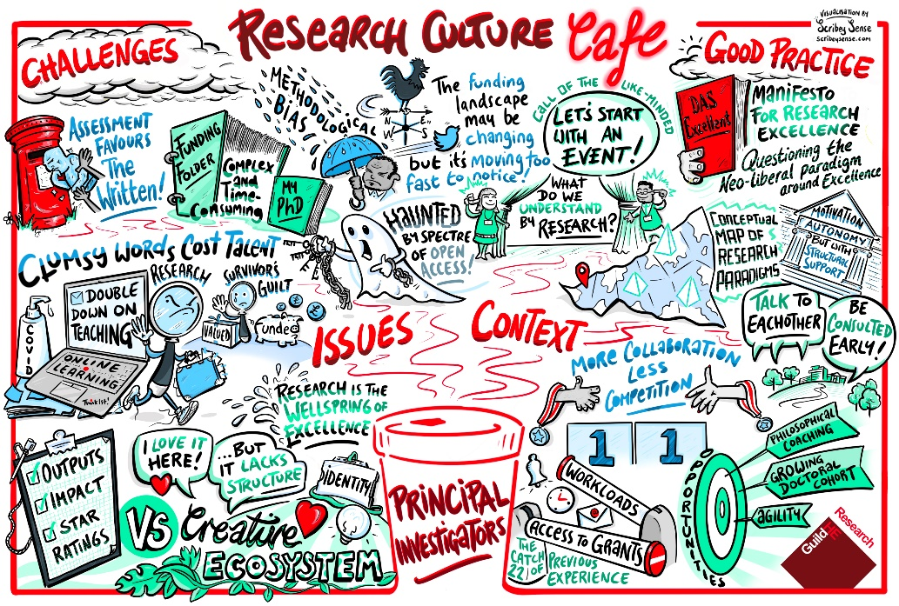
Figure 1 GuildHE Cafe, Experienced Researchers

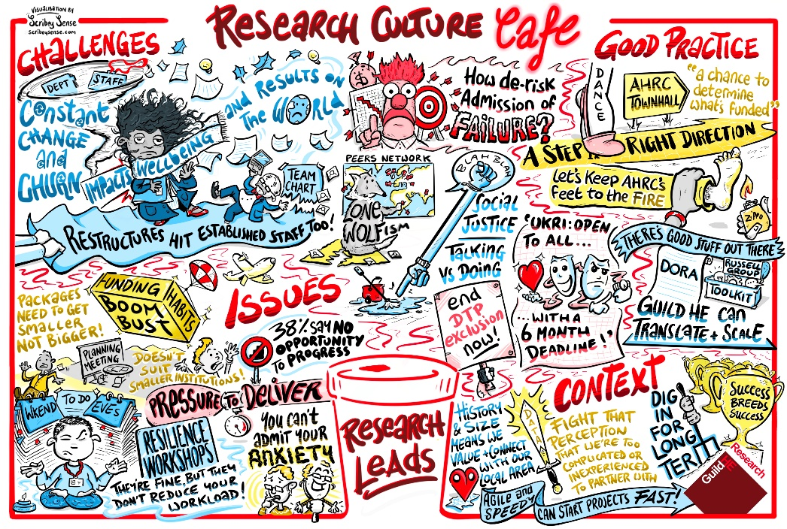
Figure 2 GuildHE Cafe, Research Managers

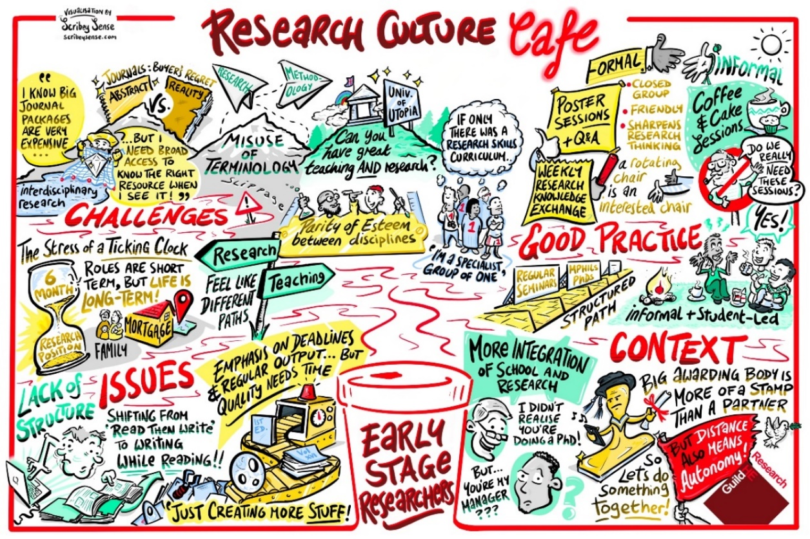
The Institutional Repository and eStudio
Figure 3 GuildHE Cafe, Early Career Researchers

  - Update on the Institutional Repository
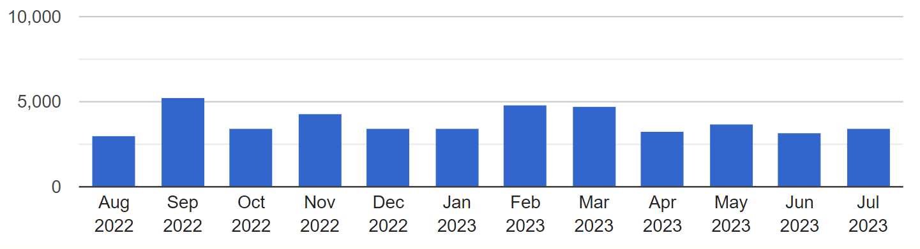
The Institutional Repository currently holds 414 research outputs - with 90% being full-text and 80% fully Open Access. The total number of downloads has reached 120,257, with 46,092 occurring in the past year (01/08/22 – 28/07/23). The monthly average for downloads comfortably sits at 3841 per month.
Repository downloads per month, 2022/23
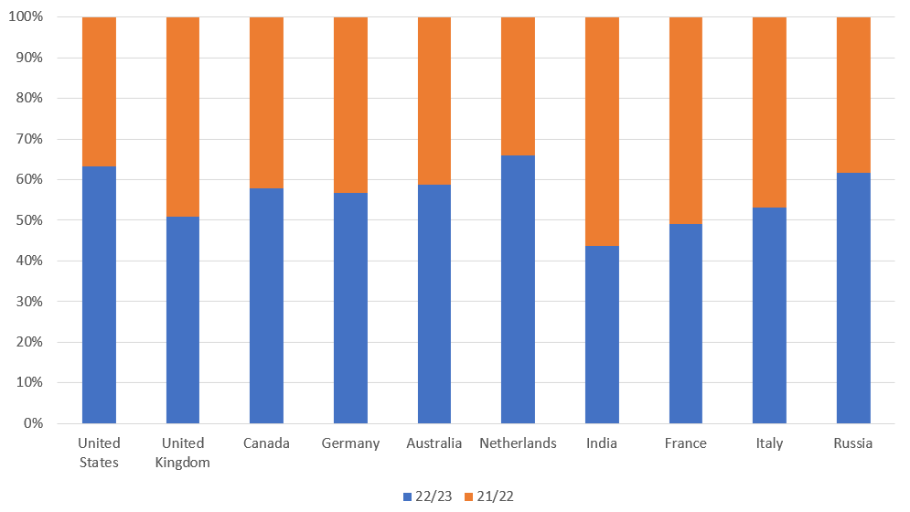
International engagement with the repository has increased since 2021/22, with the US being the main source of downloads in 2022/23. Additionally, there have been small but significant increases in downloads from other countries outside the UK.
Proportional comparison, downloads per country, 2022/23

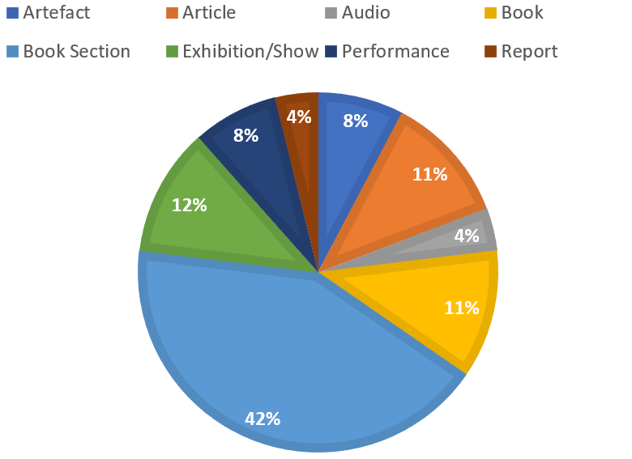
Since January 2021 (the start of this REF cycle), the research department has received 96 deposits to the Leeds Arts University Repository. Out of these: 20 occurred between 1 January and 31 July 2021, 50 occurred in 2021/22 and 26 in 2022/23. Considering the implementation of research Pathways in late 2022, a decrease in outputs due to fewer research-active staff members was expected. However, the researchers currently on the Research Pathways (24 researchers in total, 26 outputs deposited in 2022/23) are more actively engaged in depositing content to the repository compared to the previous research support model (95 researchers in total, 50 outputs deposited in 2021/22).
Of the outputs deposited to the Institutional Repository in 2022/2023, the percentages per output type are as follows:
Percentages per output type deposited, 2022/23

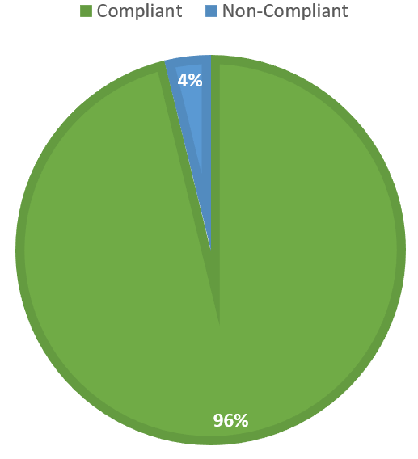
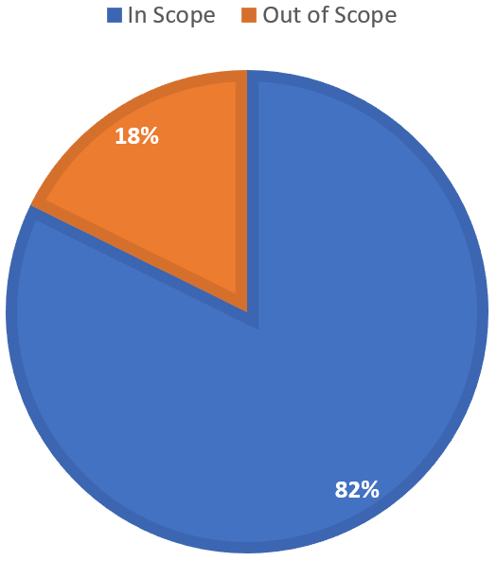
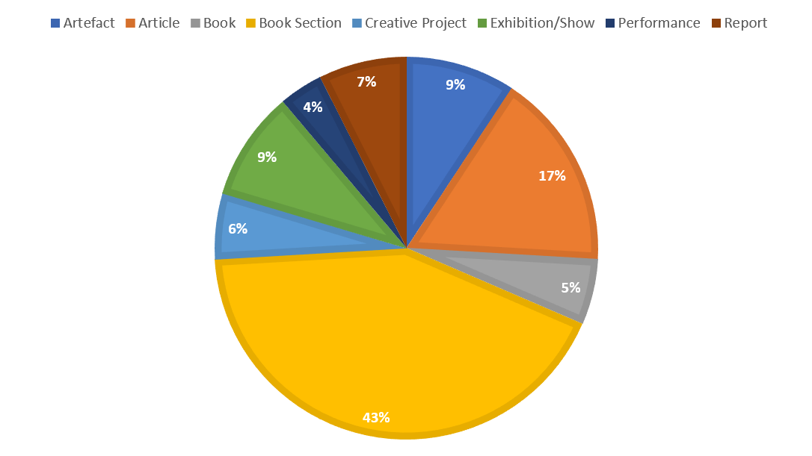
Among the outputs deposited since January 2021, 79 out of 96 are in-scope for REF 2028. Out of these in-scope outputs, 76 are compliant with national open access policy and indications of REF 2028 policy. It is estimated that out of the 76 compliant outputs, 54 are expected to achieve a quality rating of 2* or above in terms of their significance, rigour, and quality [This is only an estimation based on 2* criteria].
Outputs – In scope and Out of Scope
Outputs – In scope compliant and non-compliant
Percentages per output type, perceived REF 2* and above

The proportions of output types for the outputs that appear to be REF 2* quality in terms of units of assessment thus far is 3 in UoA 27: English Language and Literature, 47 in UoA 32: Art and Design; History, Practice and Theory, and 5 in UoA 33: Music, Drama, Dance, Performing arts, Film and Screen Studies.
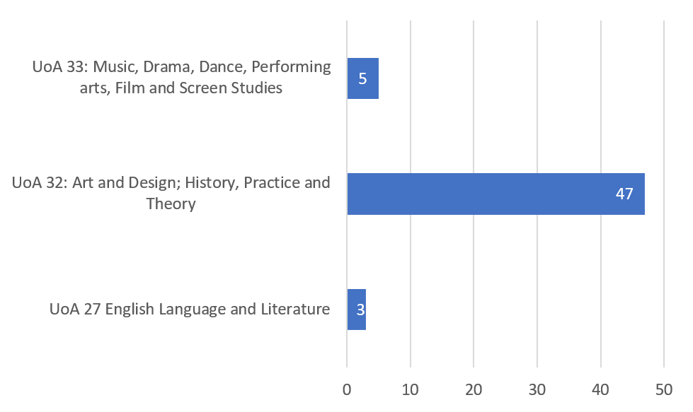
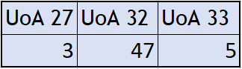
Number of perceived REF 2* outputs per Unit of Assessment

  - eStudio content updates

Updates have been made to the Research and Ethics eStudio page with a raft of new content – including guidance for navigating the changes to the UKRI Open Access policy for longform and shortform publications, with links to relevant third-party content.
In-line with the many changes to open research over the past year, Open Access Training videos from early 2022 which are now out-of-date have been moved to an archive area on the portal, whilst the videos which still reflect the current research landscape remain. Recorded content covered in the Researcher Development Sessions have replaced the videos which have been archived.

