ANNUAL RESEARCH REPORT
2020/21

Originator: Prof Sam Broadhead
Date: 06 October 2021

Contents
1) Research time and staff proposals 3
2) Bids for external funding & externally funded projects in 2020/21 3
3) External awards 3
4) Internal events 3
5) External events, exhibitions and publications by ‘teaching with research staff’ 2020-21 4
6) External events, exhibitions and publications by staff who have a significant responsibility for research as part of their role 2020-21 11
7) The Research environment: Invited talks/ reviewing/editorial work/chairing panels 15
8) Ethics 17
9) Exhibitions programming 17
10) Research Excellence Framework 2021 submission 18
11) Guild HE/Research 18
12) The virtual environment of research 18
13 Research-led teaching 19
13) Action plan progress 2020-21 20
15) Action plan 2021-2022 22

Research time and staff proposals
The overall aim of the research strategy is to enhance students’ learning by staff being engaged in their own research practices and to bring research funding into the University. Within the context of Leeds Arts University (LAU) research is investigating; rediscovering or making a new contribution to knowledge in a chosen specialist field of study/practice that is open for scrutiny through peer review. Scholarly activity is defined as surveying existing developments in the researchers’ field, these developments may be practiced- based or technical as well as academic or theoretical; acquiring knowledge in order to keep up to date with developments in a specific area. Scholarship is similar to Continuous Professional Development (CPD) but more involved and focuses on a particular area of field of work, it may involve a number of different activities and goes beyond what is strictly necessary to do ‘the job’.

In the academic year 2020-21 the University allocated specific time for research to Higher Education (HE) academic staff on permanent contracts. The basis of the allocation was 15 days for full-time staff and a proportion of this for fractional posts e.g. 0.8 = 12 days; 0.6=9 days; 0.4=6 days; 0.2=3 days.

Clear guidelines are devised requiring the submission of a research proposal and the recording of research outcomes. Proposals were submitted for approval to the Senior Management Team (SMT) and the Ethics Sub-Committee. Research activity was monitored by the Head of Research electronic copies of the proposals provide a record of proposed activity.

Bids for external funding & externally funded projects in 2020/21
In collaboration with Vikki Hill (UAL) Vicky Gunn (Glasgow School of Art), Emily Salines (UAL), Liz Bunting (UAL), Allan Atlee(Glasgow School of Art) Broadhead successfully applied for a QAA Collaborative Enhancement Project 2021. It is called “Belonging Through Assessment: Pipelines of Compassion” the project was awarded £10000.
Woolley, D. and her collaborator Zara Worth have been awarded Leeds 2023 seed funding for the project: The Web That We Want.
They are developing an exhibition and new public artwork which asks - what is the Web that We Want? The project begins in the summer of 2021.
Wooley D. 2021, and Davin Watne also received a small grant from Future's Venture Foundation to produce some short animations for Facebook and Instagram adverts based on their research.

External awards
Pearson, J. 2021. Won the Eisner Award for 'Best Painter / Multimedia Artist (Interior Art) in July 2021 for his graphic novel 'Blue in Green', published by Image Comics. [The Eisner Awards are essentially the ‘Oscars’ of the comics industry].
Norton, F. 2020. Frances Ann Norton Winter Artist of the Season, posted online 21 December 2020, Magical Women solo showcase.

Internal events
Broadhead held a session on 26 January 2021 that was chaired by Tobias-Green called ‘A writing life’ all staff were welcome. There was good attendance and feedback include: “I just wanted to say how much I enjoyed your talk. It actually made me feel quite emotional! And it was so refreshing to hear that everyone seems to be as intimidate by this as I am. This has really motivated me to get my act in gear and get something done. I also loved your idea of the writing buddy. Thanks again for your talk. I think we need more of these.” The video is available at https://web.microsoftstream.com/video/5454d7eb-cee7-4914-9e1f-0f31983690fd

Curative Things is a collaborative symposium (12 February 2021) organised by Thing Power Research Group (Leeds Arts University), Thinking Through Things (Northern Network for Medical Humanities Research, supported by Wellcome Trust), and Fashion Research Network. The symposium focused on objects at the intersections between art and fashion, health and medicine. A subsequent publication is planned.

The University held a public symposium, The Industrialisation of Arts Education, in collaboration with the University of Derby on 16 March 2021. Broadhead convened the event and Associate Professor Bill Esmond, Dr Karen Tobias Green, Michael Smith, Eleanor Smith and Jason Huxtable contributed papers on the theme. The content is now being considered by Palgrave Macmillan as part of their Palgrave Pivot series of publications.

The Horror Research Group met informally for the first time on 09 February 2021 and welcomes all academics whose research interests include horror.

External events, exhibitions and publications by ‘teaching and research staff’ 2020-21

Papers published in  peer-referenced journals/ Book chapters/Books/Conference Proceedings | Conference presentations | External  Exhibitions/screenings
Postgraduate
Oldfield, P. 2021 Women’s photography and the American Civil War: The case of Elizabeth Beachbard, ambrotypist accepted for publication in History of Photography Journal.  Norton, F. 2020. Developing critical thinking and professional identity in the arts through story. In: Practice-Focused Research in Further Adult and Vocational Education: Shifting Horizons of Educational Practice, Theory and Research. London: Palgrave Macmillan.  Norton. F. 2021. What can critical thinking do for access to Higher Education adult learners at a Further Education arts institution? Reflections on a poetry group. In: Delivering the Public Good of Higher Education – Widening Participation, Place & Lifelong Learning. FACE publications | Tobias-Green, K. 2020. Knowledge and Place: online teaching and learning and the rethinking of knowledge in a global pandemic, at The International Conference on Arts, Culture and Education 2020, Sichuan Fine Arts Institute, China, 27 November-29 November 2020.  Taylor, S. Painting Class: Lost in Transcription, at The International Conference on Arts, Culture and Education 2020, Sichuan Fine Arts Institute, China, 27 November-29 November 2020.  Sheila, G. 2020. Embodied Dreaming the London-Irish Mantelpiece  at The International Conference on Arts, Culture and Education 2020, Sichuan Fine Arts Institute, China, 27 November-29 November 2020.  Norton, F. 2020. Critical Thinking/ Critical Making: Giving Critical Thinking a Home in HE Arts Education, Developing Criticality with Master of Arts Students, at  The International Conference on Arts, Culture and Education 2020, Sichuan Fine Arts Institute, China, 27 November-29 November 2020  Sykes, J. 2020. Home, at The International Conference on Arts, Culture and Education 2020, Sichuan Fine Arts Institute, China, 27 November-29 November 2020.  Sykes, J. 2021. Home portrait (curated exhibition). Art Hostel, East Leeds Arts. April 2021. https://www.eaststreetarts.org.uk/wp-content/uploads/2021/01/Terms-and-Conditions-of-participating-in-HOME-080321.pdf  Tobias-Green, K. 2021. At the centre of the storm: Arts writing and the industrialised curriculum. The Industrialisation of Arts Education. Leeds Arts University and the University of Derby. 16 March 2021.  Norton, F. 2020. Mature Art Students Developing Critical Thinking. Aspiration and constraint in the post-COVID post-compulsory crisis. BERA SIG (Post-Compulsory and Lifelong Learning) 05 October 2020.  Norton, F. 2021 What can critical thinking do for access to Higher Education adult learners at a Further Education arts institution? Reflections on a poetry group. (Presentation) At book launch of Delivering the Public Good of Higher Education – Widening Participation, Place & Lifelong Learning. FACE publications. 25 March 2021.  Norton, F. 2021. Wicked Problems in a Pop-up Exhibition: Reflections on a Critical Thinking Club. International Practice-Focused Research in Education Conference. Education and Training Foundation/SUNCETT. 6-8 July 2021.
Art and Performance
Ward, J.B., 2019. Who remembers post-punk women?. Punk & Post Punk, 8(3), pp.379-397. [New member of staff]  Barker, G. 2020. Drawing age, Drawing: Research, Theory, Practice (5)2: 351-361. DOI: https://doi.org/10.1386/drtp_00043_1  Barker, G 2021. Revealing the invisible: The virus is looking at you. Journal of Visual Political Communication, 77 (11). pp. 61-87.  Chambers, P. (2020) ‘Folding Chair for the Feminist Resistance: Activating Feral Materiality’, Feminist Visual Activism and the Body. Edited by Basia Sliwinska. Routledge.  Palin, T. 2020. Beyond Other Horizons: Exhibition Catalogue. Iasi, Romania. | Huxtable, J. 2021. ‘Performance’ measures as assault on music education: A policy archaeology of the teaching excellence framework. The Industrialisation of Arts Education. Leeds Arts University and the University of Derby. 16 March 2021.  Hooper, S. 2021. Reaching Audiences in 2020. Cumulus, Roma, Virtual Conference 8-11 June 2021.  Hooper, S., Tobias –Green, K. and Broadhead, S. 2021. A Conversation about Ethics [Video Essay]. Media Practice Education/Media Communications and Cultural Studies Association. Solent University, Southampton. 21-25 June 2021. | Cumberland, K. 2020. Drawing installation on gallery frontage. Galería Mercado Negro, Cholula, Puebla, Mexico, October-November 2020.  Steans. D 2020. Re-shift, Re-calibrate, Pavilion, Leeds [online]; in March 2021 I presented work at Come Together, Workplace Gallery, Gateshead/London [online].  Virgoe, A. 2020. Two paintings in Biennial Exhibition of Painting, Swansea, South Wales: 03 Otober-07 November 2020.  'Puppy the Goblin ENGLISH SUBS' is a commissioned video work, presented publicly as part of Pavilion's online moving image festival 'Re-shift, Re-calibrate' (Aug 2020).  Barker, G. (2020). ‘Neither fish nor fowl’, Invasive Species. Harlow Carr, Harrogate. 1 September 2020 – 3 January 2021.  Cooke, L. 2020. was selected by Art & Heritage to take part in Blue Sky Museums with the Bronte Parsonage.  Cooke, L. (2020) ‘A Still – Volcano – Life’, Invasive Species. Harlow Carr, Harrogate. 1 September 2020 – 3 January 2021.  Chambers, P. 2021. Lacking Charm. Curative Things poster project. February 2021.
Lens Based Practices
Adiloğlu, F., Fragiacomo, F. and Petricone, F., 2020. Distance Artist: Building the Skills of Future Creatives. Developing Evidence‐Based Criteria for Global Virtual Team Tutoring and Management in Art and Design Education, International Journal of Art & Design Education. DOI: https://doi.org/10.1111/jade.12336  Eyre, S., & Hutchinson, X. (2021). Re-touched. Fashion, Style & Popular Culture, 8(2-3), 205-210. | Allen, M. (2021). The art of following instructions, The International Symposium for Autoethnography and Narrative Enquiry, Florida, (online) 2-3 January 2021. |  | Armstrong, L. 2021. Office Exercises. Curative Things poster project. February 2021.  Welding, P. Home Occupations. FORMAT International Photography Festival. 12 March 2021 – 5 March 2023.  Eyre, Sarah (2020) Twitch, shift, jerk, slip, repeat. [Video]  Open Eye Gallery’s website: https://openeye.org.uk/blog/new-commissions-how-will-we-remember/ It was also shared via the University of Salford’s Art Collection website. https://artcollection.salford.ac.uk/online-covid-commissions/ The project was also selected for Peer to Peer UK/HK digital festival https://peertopeerexchange.org/existing-works
Fashion & Textiles
Slater, L. 2021. Eye: Sharing Narratives, Collaborative Image Making and Applied Illustration. 11th Illustration Research Symposium, Kingston University, London. 11-12 February 2021.

Snare, E. 2021. Desperate enterprises. The Industrialisation of Arts Education. Leeds Arts University and the University of Derby. 16 March 2021.

Grain, E. 2021. 3D Digital Fashion Design & Prototyping Towards a
Sustainable Fashion Future. 2nd Digital Fashion Innovation E-Symposium 2021. MMU. 18 June 2021.

Stewart, T. 2021. 1940s-50s ‘Americas’ print collection, Bradford Textile Archive. 13 April 2021.
Lane, C. 2021. Object, Potentiality and the Possibilities of Re-imagination – a playful exploration of the derelict through the re-making of found objects. Session title “Geographies of collecting, gleaning and rummaging” RGS -IBG Annual Conference 2021, London: 31 August – 03 September 2021 [online].
Communication Design
Spawforth-Jones, S. 2021. Utilising mood boards as an image elicitation tool in qualitative research. Sociological Research Online (2021): 1360780421993486.  Chalmers, R. (2020). ‘Opalini Lassellii’, in Eaton, J. (ed.) Almost Real: A Speculative Biology Zine, Volume 3: Aquatics. Seattle: Fortuna Media, pp. 13-18. | Jones-Barlow, K. 2021. Close reading: Ahistorical illustrative research, at Education and Illustration: Models Methods Paradigms, 11th Illustration Research Symposium, online, 11-12 February 2021.  Mills, J. Twists and loops: Illustrating ecologically at Education and Illustration: Models Methods Paradigms, 11th Illustration Research Symposium, online, 11-12 February 2021.  Smith, M. 2021. The impact of industry on animation education. The Industrialisation of Arts Education. Leeds Arts University and the University of Derby. 16 March 2021.  Simpson, B. 2021. BooBoo’s Vision( A visual exploration of the world through the eyes of a child.) Children’s Media Conference. 5-9 July 2021.  Simpson, B. 2021. ‘TootSuite’: A visual exploration of the world through the gaze of a cartoonist’s child. CLE Symposium 2021: Playfulness. 13-14 May 2021.  Chalmers, R. (2021). ‘Creature Design Methods’, in 14th Animation Festival, Faculty of Fine Arts, Cartoon and Animation Department, Kütahya Dumlupinar University, Turkey, 28 to 30 April 2021. | Chalmers, R. 2021. Mentor [Exhibition]. Faculty of Fine Arts, Cartoon and Animation Department, Kütahya Dumlupınar University, Turkey, 11 to 25 January 2021.  Mills, J. and Karol, B. 2021. A piece of turf, Yorkshire Artspace, Sheffield: 20 May 2021- 6 June 2021.  - Chalmers, R. 2020. Halloween Discord Drawing Jam [Exhibition] LightBox Expo and The Concept Art Association, 30 October 2020.

External events, exhibitions and publications by staff who have a significant responsibility for research as part of their role 2020-21
Papers published in  peer-referenced journals/ Book chapters, Books, Conference Proceedings | Exhibitions and Screenings | International and National  conference presentations
Broadhead, S. 2021. ‘Mature graduates and visual culture learning communities: Working through the covid-19 pandemic’, Hongxia Shan and Cindy Hanson (eds.) Proceedings of Adult Education in Global Times, Vancouver, University of British Columbia: 92-97. ISBN: 978-0-920056-54-7.  Broadhead, S. 2020. What Eliza and Jake did next: Learning beyond access to HE art and design? Merrill, B.,Vieira, C.C., Galimberti, A. and Nizinska, A.(eds) Adult Education as a Resource For Resistance and Transformation: Voices, learning experiences, identities of student and adult educators. Coimbra, Faculty of Psychology and Education Sciences, University of Coimbra, Portugal, Centre for the Research on Adult Education and Community Intervention (CEAD), University of Algarve, Portugal, ESREA - European Society for Research on the Education of Adults. pp. 167-174. ISBN 978-86-80712-40-6  Broadhead, S. 2020. ‘Mature students matter in art and design education’, John P Egan (ed.) Proceedings of Adult Education in Global Times, Vancouver, University of British Columbia: pp. 75-81. ISBN 978-0-920056-53-0.  Broadhead, S., 2020. Non-traditional students and Practical Wisdom a perspective from a practitioner-researcher. In: Practice-Focused Research in Further Adult and Vocational Education: Shifting Horizons of Educational Practice, Theory and Research. Palgrave Macmillan pp. 57-75.  McAra, C. (2021) ‘Open Sesame: Dorothea Tanning’s Critical Writings’, Surrealist Women’s Writing: A Critical Exploration. Edited by Anna Watz. Manchester University Press. https://manchesteruniversitypress.co.uk/9781526132024/.  McAra, C. (2021). ‘Curating Fictional Activism: In-Conversation with Michelle Williams Gamaker’, So Anyway Magazine, issue 8.  Baines, M. 2020. ‘Their Defining Moments. Identifying critical influences that prompted progression in post compulsory education in the Arts’ In: Practice-Focused Research in Further Adult and Vocational Education: Shifting Horizons of Educational Practice, Theory and Research. Palgrave Macmillan. https://doi.org/10.1007/978-3-030-38994-9_6 | Woolley, D. 2020. Ways of Protest, Swansea, 20 November 2020 -16 January 2021.  Woolley, D. 2021 Consumed: Still Lives. Perth Centre of Photography. March 2021.  Woolley, D. 2021. Curative Things poster project. February 2021. | Broadhead, S. 2021. Using a Community of Inquiry approach to examine the experiences of Black, Asian and Minority Ethnic students in Further Education art and design courses. International Practice-Focused Research in Education Conference. Education and Training Foundation/SUNCETT. 6-8 July 2021.  Hooper, S., Tobias –Green, K. and Broadhead, S. 2021. A Conversation about Ethics [Video Essay]. Media Practice Education/Media Communications and Cultural Studies Association. Solent University, Southampton. 21-25 June 2021.  Broadhead, S. 2021. Eliza’s story about assessment. QAA Collaborative Project Launch. Belonging Through Assessment: Pipelines of Compassion. Online with UAL and Glasgow School of Art. 10 June 2021. (49 attendees)  Broadhead, S. 2021. Mature graduates and visual culture learning communities: Working through the covid-19 pandemic. Adult Education in Global Times, an international conference, online. The University of British Columbia, Vancouver, Canada. 3-6 June 2021.  Broadhead, S. and Da Costa, L. 2021. Drawing upon a Community of Inquiry approach to explore Evidence and Impact conference, Go Higher West Yorkshire. 19 May 2021. (45 attendees)  Broadhead, S. and Da Costa, L. 2021. Drawing upon a Community of Inquiry approach to explore Black, Asian and minority ethnicity student experience. APS 6th Biennial International Conference. 18 March 2021.  Broadhead, S. 2021. Mature graduates and VCLCs and Covid-19. Access, Participation and Success, 6th Biennial International Conference. 18 March 2021.  Broadhead, S. and Da Costa, L. 2021. Drawing upon a Community of Inquiry approach to explore Black, Asian and minority ethnicity student experience. Addressing race inequality in higher education, Go Higher West Yorkshire. 09 March 2021.  Broadhead, S. 2021. The Role of Art, Craft in and Design in prison education:  A practitioner’s perspective. APPG Art, Craft and Design Education. 01 March 2021.  Broadhead, S. 2020. Mature Students and Visual Culture Learning Communities in Covid19 Pandemic. The International Conference on Arts, Culture and Education 2020, Sichuan Fine Arts Institute, China, 27 November-29 November 2020.  Broadhead, S. 2020. Mature Students and Visual Culture Learning Communities in Covid19 Pandemic. Aspiration and constraint in the post-COVID post-compulsory crisis. BERA SIG (Post-Compulsory and Lifelong Learning) 05 October 2020.  Woolley, D. 2020. Bois of Isolation - queering gender binaries in the confines of pandemic, at The International Conference on Arts, Culture and Education 2020, Sichuan Fine Arts Institute, China, 27 November-29 November 2020.  Baines, M. 2020. Bruce’s Story. Aspiration and constraint in the post-COVID post-compulsory crisis. BERA SIG (Post-Compulsory and Lifelong Learning) 05 October 2020.  Baines, M. 2021. Their Defining Moments’: Critical incidents and influences for progression into post compulsory education in the Arts. International Practice-Focused Research in Education Conference. Education and Training Foundation/SUNCETT. 6-8 July 2021.

The Research environment: Invited talks/ reviewing/editorial work/chairing panels
Invited talks
Attah, T. was asked to Music Talks participating in a recital and an interview with Diana Gilchrist at the Bader Institute, Queen’s University of Canada, 16 December 2020.
Attah, T. was also invited to lecture about, Never-Ending Stories: Narratives and Myth-Making in Popular Music Culture, at Napier University, 10 March 2021.
Simpson, B was asked to present a keynote, ‘Trends of Animation Education and the Challenges of Entering the Animation Industry’. For Innovation Digital Design Conference, Taiwan, 28 May 2021.
Broadhead, S. 2021. Eliza’s story about assessment. QAA Collaborative Project Launch. Belonging Through Assessment: Pipelines of Compassion. Online with UAL and Glasgow School of Art. 10 June 2021. (49 attendees)
Broadhead, S. and Da Costa, L. 2021. Drawing upon a Community of Inquiry approach to explore Evidence and Impact conference, Go Higher West Yorkshire. 19 May 2021. (45 attendees)
Broadhead, S. and Da Costa, L. 2021. Drawing upon a Community of Inquiry approach to explore Black, Asian and minority ethnicity student experience. Addressing race inequality in higher education, Go Higher West Yorkshire. 09 March 2021.
Broadhead, S. 2021. The Role of Art, Craft in and Design in prison education: A practitioner’s perspective. APPG Art, Craft and Design Education. 01 March 2021.

Panel Chairs and members
Broadhead was panel chair and on organising team at the International Practice-Focused Research in Education Conference. Education and Training Foundation/SUNCETT. 6-8 July 2021.
Oldfield, P. led a panel discussion with photographers Newsha Tavakolian (Iran), Alison Baskerville (UK) and Rena Effendi (Azerbaijan) at Don McCullin retrospective at Tate Liverpool, 15 October 2020.
Gaffney, S. 2021. Leeds International Piano Competition. As part of the organisation's 2021 programme Professor Gaffney recently contributed guidance and time as a panel member for the selection of visual artists to develop a 10-point sculpture trail across the city, each supported by a playable piano. The sculptures will be built from upcycled pianos and the playable pianos which will respond to the sculptures will be shaped by local artists and community groups.

Review work
Grain, E. has undertaken peer review for Clothing and Textile Research Journal (SAGE).
Grain, E. has reviewed for Journal of Fashion Marketing and Management.
Broadhead, S. has undertaken peer review for Journal of Social Sciences (mpdi)
Chalmers, R. was a book reviewer for Cognition – The Thinking Animal, 4th Edition, Cambridge University Press, January 2021.

Editorial work
Broadhead, S. (2017-2021) continued her Appointment to the Editorial Board, Journal of Widening Participation and Lifelong Learning
Broadhead S., Butcher J., Davison E., Fowle W., Hill M., Martin L., McKendry S., Norton F., Raven N., Sanderson B., Williams SW. (eds) 2021. Delivering the Public Good of Higher Education – Widening Participation, Place & Lifelong Learning. FACE publications.

Pathway to impact activity

Broadhead developed evidence sessions for APPG art, craft and design education and contributed to writing up reports 2020-2021. Broadhead is part of a steering group for an upcoming Report for the All-Party Parliamentary Group for Art, Craft and Design Education. The first session for seeking evidence was on 17 November 2020. Broadhead is planning with the group’s secretary Susan Coles a session focused on further education’s contribution to the cultural industries pipe line of skill and talent.

Broadhead was appointed a trustee on the Brigantia Board. The aim is that West Yorkshire becomes a place where the people create and commission fantastic and accessible arts and cultural activities; making art a part of everyday life.

Broadhead led a research strand of a larger project managed by SUNCETT and sponsored by the ETF: What have we learned from the Practitioner Research Programme? The strand: Pedagogic rights, access and widening participation, the overall aim will be to write a parliamentary report on behalf of the ETF.

Attah, on 06 November 2020 presented Who's Blues-understanding Black music and culture a public engagement talk at Lindy Fridays, Leeds. 100 attended online.

Attah will lead the first Popular Music Study Group at the Royal Music Association. He now has a seat on the RMA council – (they have not previously appointed a popular musician in nearly 200 years).

Attah is a member of RMA’s EDI committee and has co-authored the EDI survey for their membership.

Barker presented, also on 06 November 2021, Making Votives: pain and practice, response to community needs at Beyond Measure, Cultural Institute, University of Leeds. Baker, G. 2020. Making Votives: pain and practice, response to community needs can be found here: https://thevotivesproject.org/2020/09/15/making-votives/

Woolley, D. and Davison, A.C. 2021. Selfie workshops in relation to the Bois of Isolation Project.

McAra, C. (13 September 2020) ‘A Feminist Marvellous’ for The Debutante. Webinar, public-facing, ticketed, 48 attendees https://www.thedebutante.online/events-1

Ethics
Research proposals for the upcoming academic year 2020-2021 were reviewed by the Ethics Sub-Committee. Proposals where the ethical questions had not been considered were given conditional approval on addressing any outstanding ethical issues.

The University has put into place all the requirements necessary in order to be compliant with the Research Integrity. As a minimum, this means that it must be able to demonstrate:
- identified a named point of contact who will act as a first point of contact for anyone wanting more information on matters of research integrity, and ensure that contact details for this person are kept up to date and are publicly available on the institution's website .
- provided a named point of contact or recognised an appropriate third party to act as confidential liaison for whistle-blowers or any other person wishing to raise concerns about the integrity of research being conducted under their auspices.
- published an annual statement on how they are meeting the requirements of the revised concordat.
The University is required to publish an annual statement that has been approved by the Senior Management Team. The annual statement here: https://www.leeds-art.ac.uk/research/research-integrity-ethics/
Compliance will be reported to Universities UK via GuildHE/Research as part of our membership. This year there have been no external queries about our researchers’ ethical practice. Internal issues have been dealt with through the Ethics Sub-Committee.

Exhibitions programming
The programme has been suspended due to the pandemic, however a series of poster campaigns were commissioned that were shown around Leeds in February 2021. This was to accompany Curative Things: Medicine / Fashion / Art the online Symposium

Research Excellence Framework 2021 submission
The University made its first REF submission on 19 February 2021 over a month before the deadline of 31 March 2021. This is a significant achievement for the institution and provides a foundation for future research strategy and policy. The amount of staff (from all departments) time and commitment in supporting the submission is recognised and appreciated. It is anticipated that the results will be published in April 2022 when it will be seen if the KPI of 20% of the overall submission achieving 2* or above has been met. At this point the University’s research strategy will be reviewed.
The final Code of Practice, Personal Circumstances report and Equality Impact Assessment reports have been submitted on 17 June 2021 via Survey Monkey.
The staff audit sample for REF 2021 was requested in June. This included Category A submitted staff returned to the REF, and also included former staff who are listed against submitted outputs, and staff who appear to be Category A eligible in the C19025 HESA return who were not returned to the REF. Evidence that our submission of ECRs as non-returnable was sent by the deadline 02 July 2021. On then 12 July 2021 the Head of Human Resources was informed by the REF Audit Team that no changes to REF data are required following their review of the evidence provided.
An audit file for other aspects of the submission has been created by the Research Coordinator. This file contains descriptions of procedures and the rationale for decision making as regards outputs and impact case studies.

Guild HE/Research
The Head of Research continues to attend regular meetings with GuildHE/Research. The University continues to subscribe to shared resources such as the Repository and membership of Vitea.

Open access 2020-21
During this academic year there have been 22,590 down loads, the chart below show the number of downloads per month which for the majority of time remains relatively constant. The number of downloads by country shows the vast majority are from the United Kingdom flowed the United states. Surprisingly, Romania is the third largest number of down loads. Overall 117 countries have engaged with the repository, so the reach is very good.

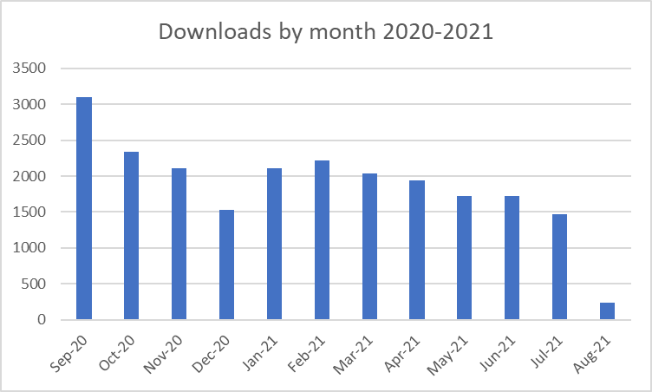

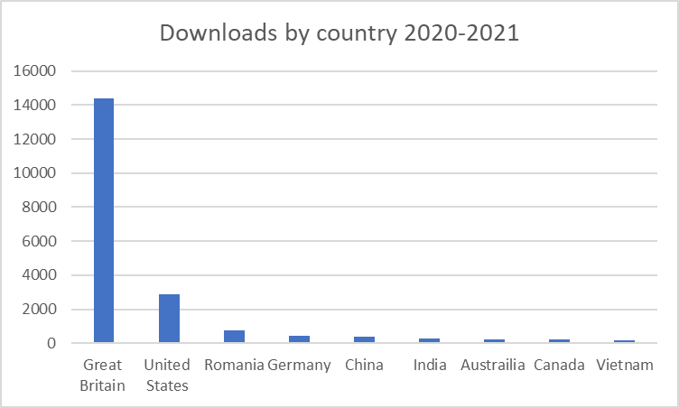

The chart showing the different types of output indicates that exhibitions are a large section of the output pool followed by article. This academic year 26 outputs have been deposited 100% were ‘full-text’ versions meaning that the content of the output is in the repository. Currently 46% are open access. This means that 54% are either under embargo or are waiting of additional metadata or decisions about licences.

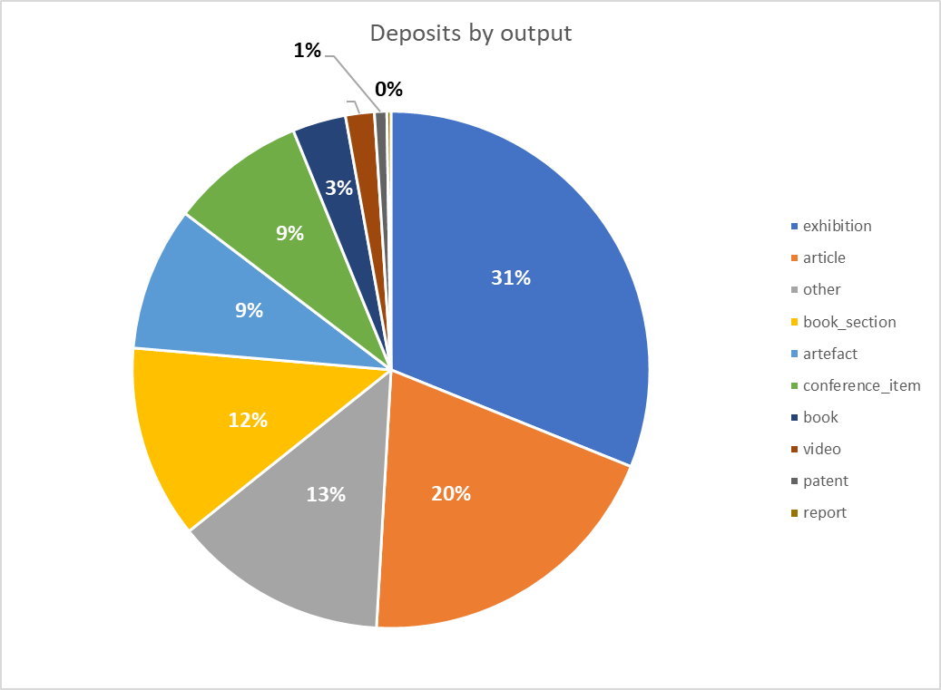

The number of deposits per month, show that there was a constant flow of work undertaken. However, after May there is a drop in the number of deposits due to a new Research Coordinator’s being recruited.
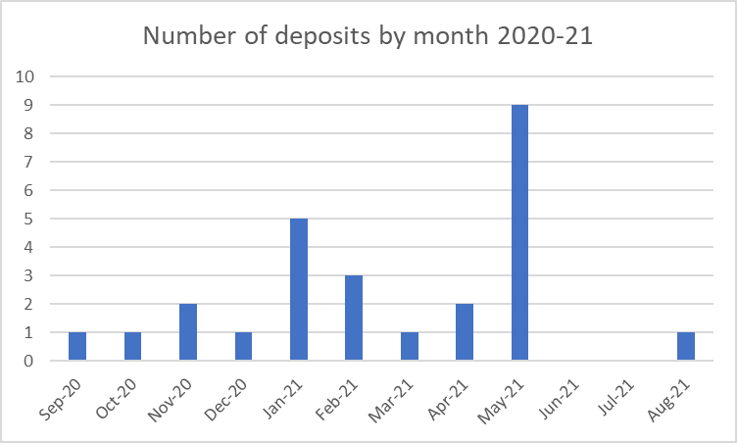

13 Research-led teaching
In the interests of managing academic staff’s workload during the pandemic the research proposal was reduced. This year staff were not required to report on how research had informed their teaching in 2020-2021. Therefore, there is no data available at this point in the year.

Action plan progress 2020-21

Objective | Action | Progress
Successful submission to REF2021 in accordance with new deadlines (31 March 2021).  Ensure by 1 June 2021 redacted versions of impact case studies and corroborating evidence held for impact case studies is submitted.  Ensure staff circumstances report, equalities impact assessment, and final Codes of practice are submitted by 30 July 2021. | Write institutional and Unit of Assessment environment statements.  Prepare 8 Impact Case studies.  Identify and record staff circumstances for final report.  Prepare an equality impact assessment based on Cat. A staff submitted.  Comply with audit requirements.  Act in line with Code of Practice that the outputs are seen at Research Committee and Academic Board.  Be mindful of deadlines to ensure processes are done in good time. | All environment statements were written and submitted 19 February 2021.  8 impact case studies were written and submitted 19 February 2021.  Staff circumstances report was submitted 17 June 2021 on Survey Monkey.  Equality Impact reports were submitted 17 June 2021 on Survey Monkey.  Audit files have been created describing processes and procedures. First HR audit on personal circumstances (ECRs) who were not required to submit outputs, was completed successfully on 12 July 2021.  Submission was undertaken in line with the Code of Practice and received at Research Committee and approved by Academic Board.  All deadlines were met.
Maintain and develop University research culture. | Reflect on and evaluate current performance.  Develop new research strategy in light of past experience gained from 2021 submission.  Continue to support researchers at the University.  Continue systematic inductions for new staff.  Continue research events. | This will be under taken when theREF2021 results are published in April 2022.  HoR and RF have continued to mentor ECRs  Systematic inductions have been undertaken.  Research events carried on during the pandemic.
Develop the virtual environment for Research | Monitor and review the information on Portal, website and eStudio. | The research coordinator has kept the information on the website, portal and eStudio current.
Develop policies and procedures for PhD to be scrutinised through stage 2 of OU Affiliated Research Centre approval process. | Develop a research integrity policy and procedure which may be part of a particular Code of Practice for research students.  Develop and ethics review process for student proposals.  Develop supervision processes and training.  Identify suitable mentors for new PhD supervisors.  Integrate the OUs regulations for research students into the University’s systems.  Develop a suitable panel for selecting PhD candidates.  Develop an appropriate resource and space for PhD students. | The University is in investigating a second possible validating partner after the OU suspended its validating activity.

Action plan 2021-2022
Objective | Action | Responsibility
Induct and support new Research Coordinator | - Recruit suitable candidate.  - Ensure they are inducted into the culture of the University including its policies and procedures.  - Ensure that effective line management support is available to the RC.  - Develop the RC so they can manage research finance requests, manage bookings on University system, manage the repository and open access processes and manage the digital environment for research.  - Support the RC in providing relevant data and reports related to Open Access. | PVCA and HoR
Develop research environment. | - Thriving research groups.  - Differentiation between three UoA research cultures.  - Research Fellows continue to support the wider research environment. | HoR, RF
Identify and work with partner to develop regulation, policy and procedures related to doctoral study at the University. | - Submit documents for scrutiny of proposed partner.  - Sign an agreement with the validating partner that serves the interests of both parties.  - Design policies and procedures for PhD students.
Evaluate REF2021 performance and create updated and responsive research strategy. | - Review and evaluate the outcome of REF2021 (April 2021).  - Give some time and space to create critical distance so that a focused and responsive research strategy can be design.  - Disseminate the Strategy through the deliberative structure. | PVCA, HoR, Research Committee

